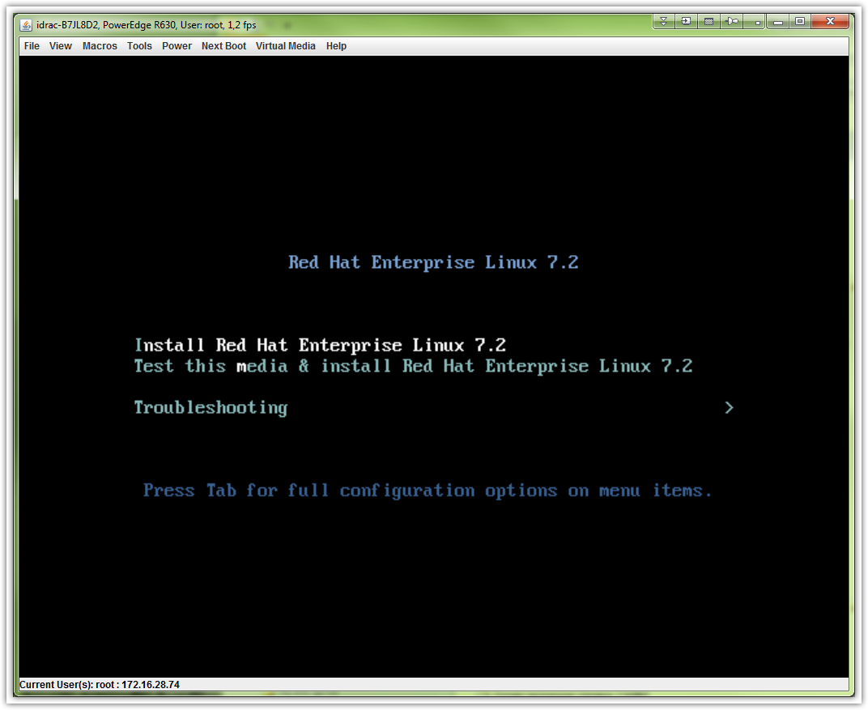

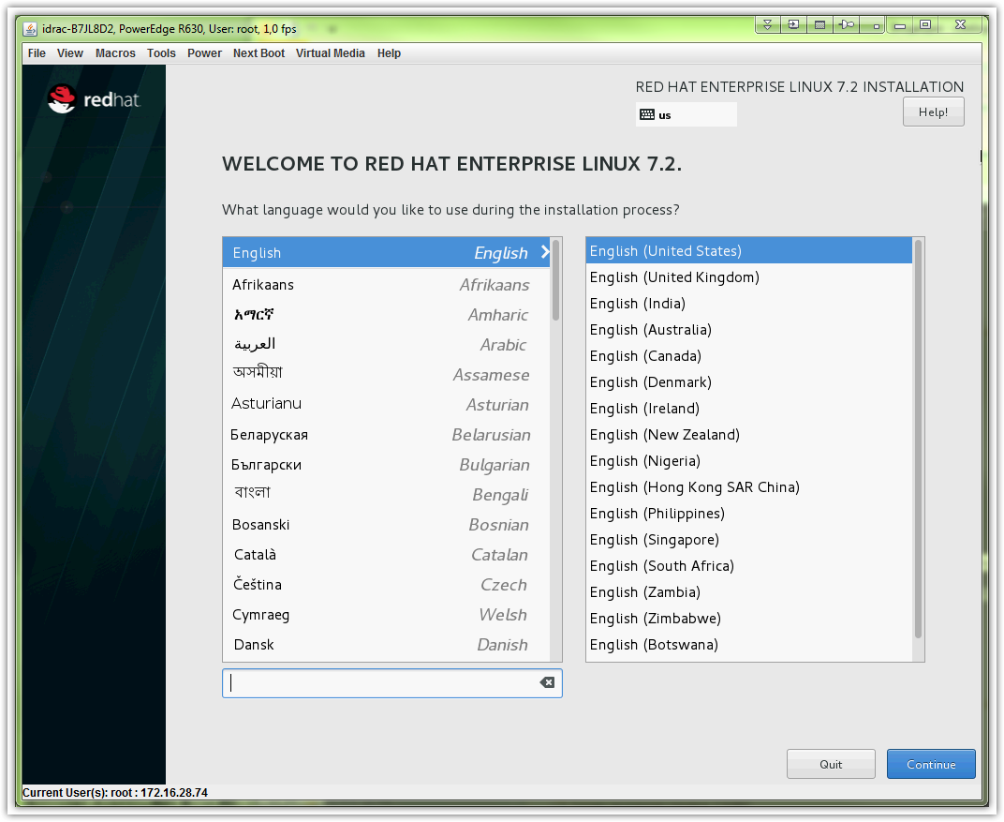

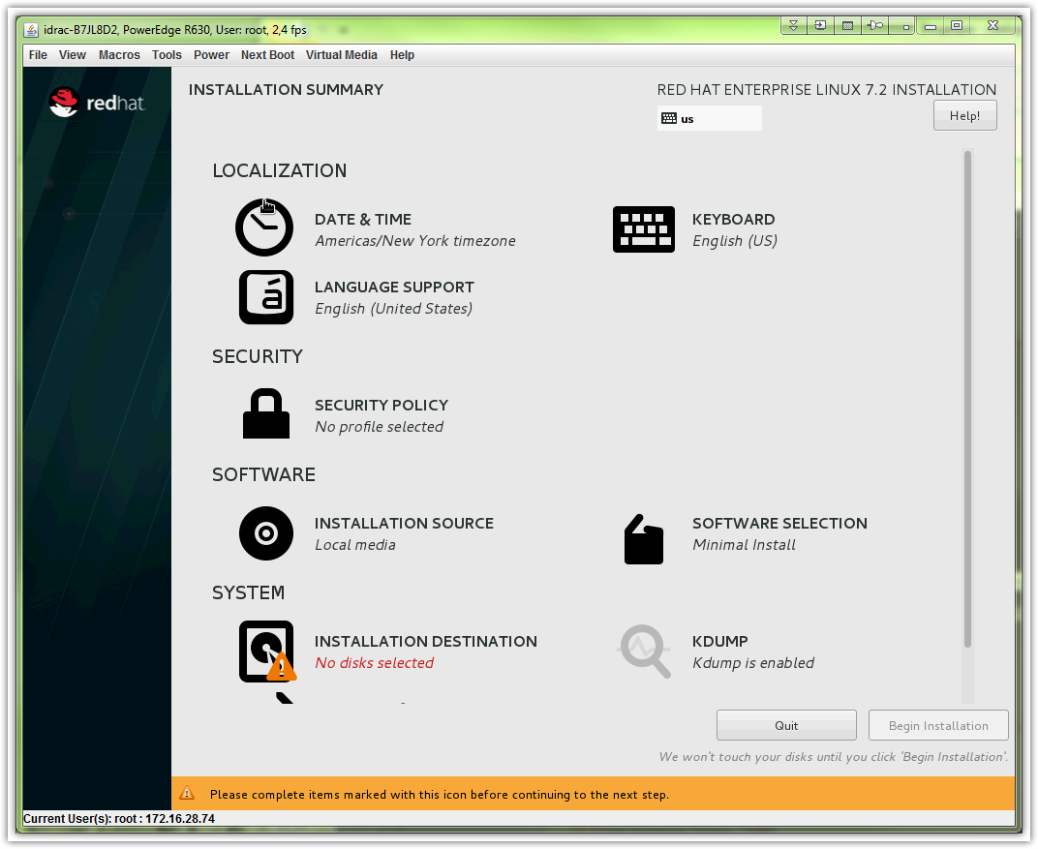

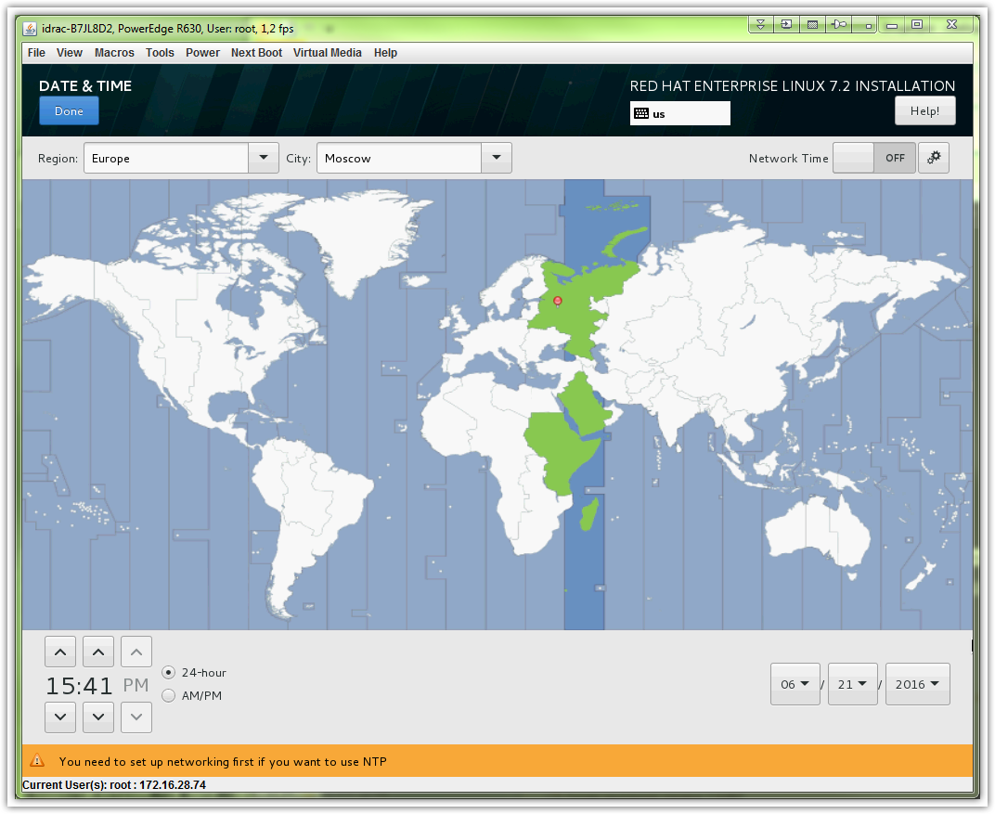

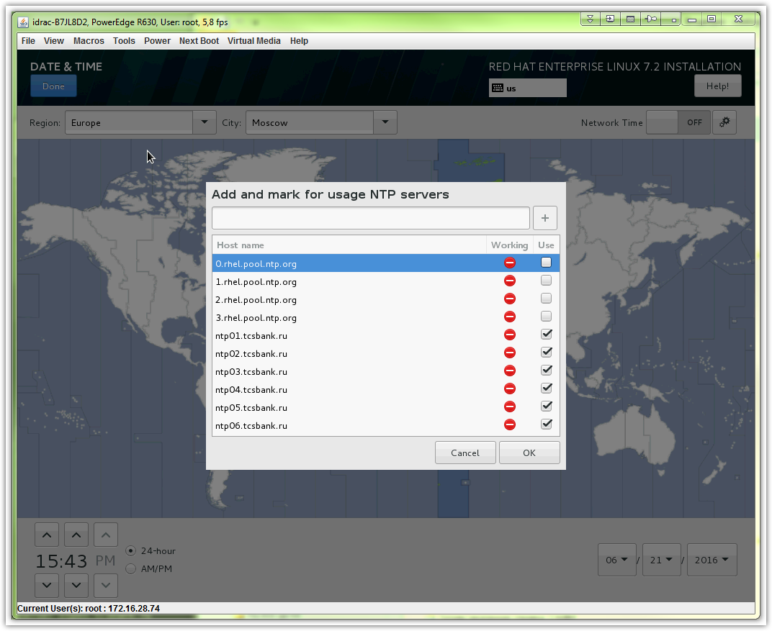

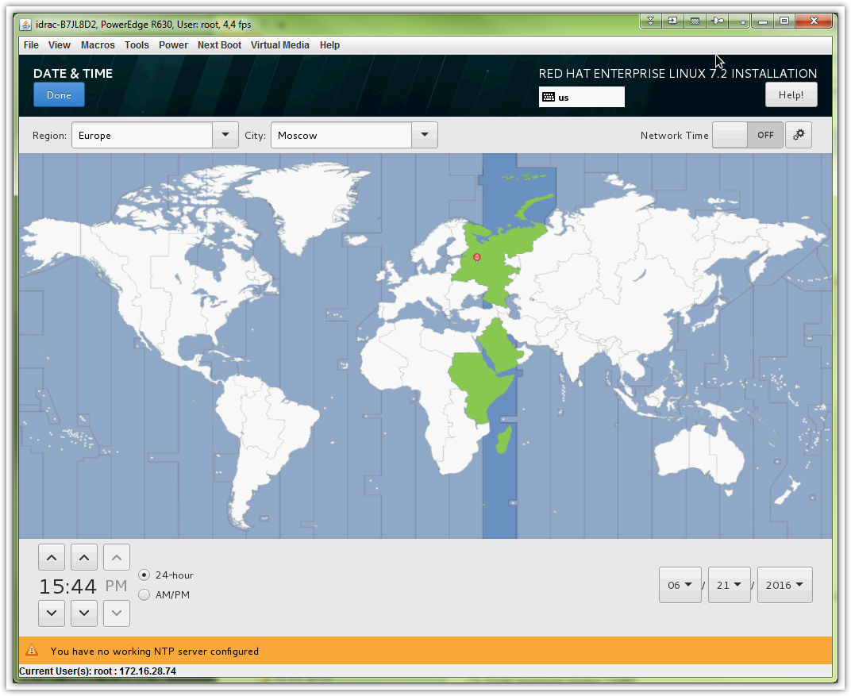

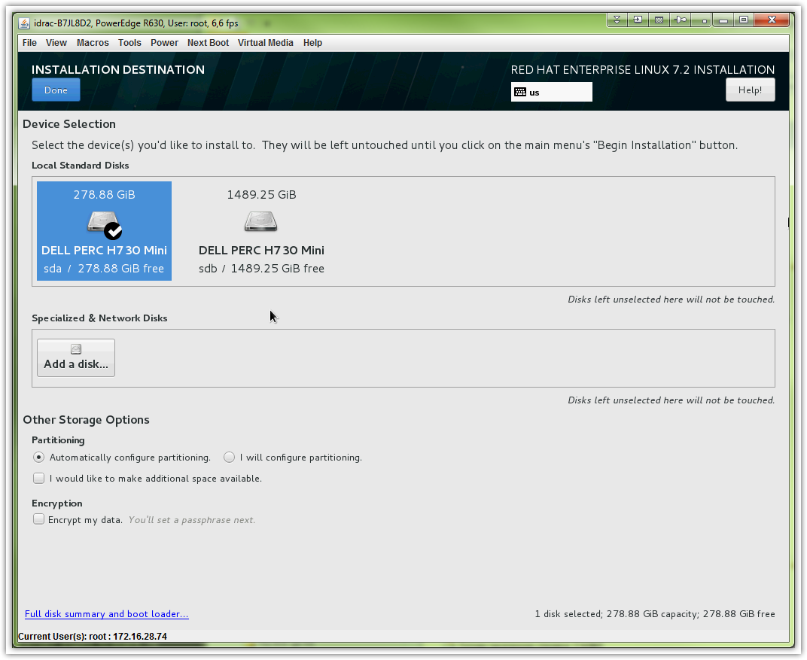

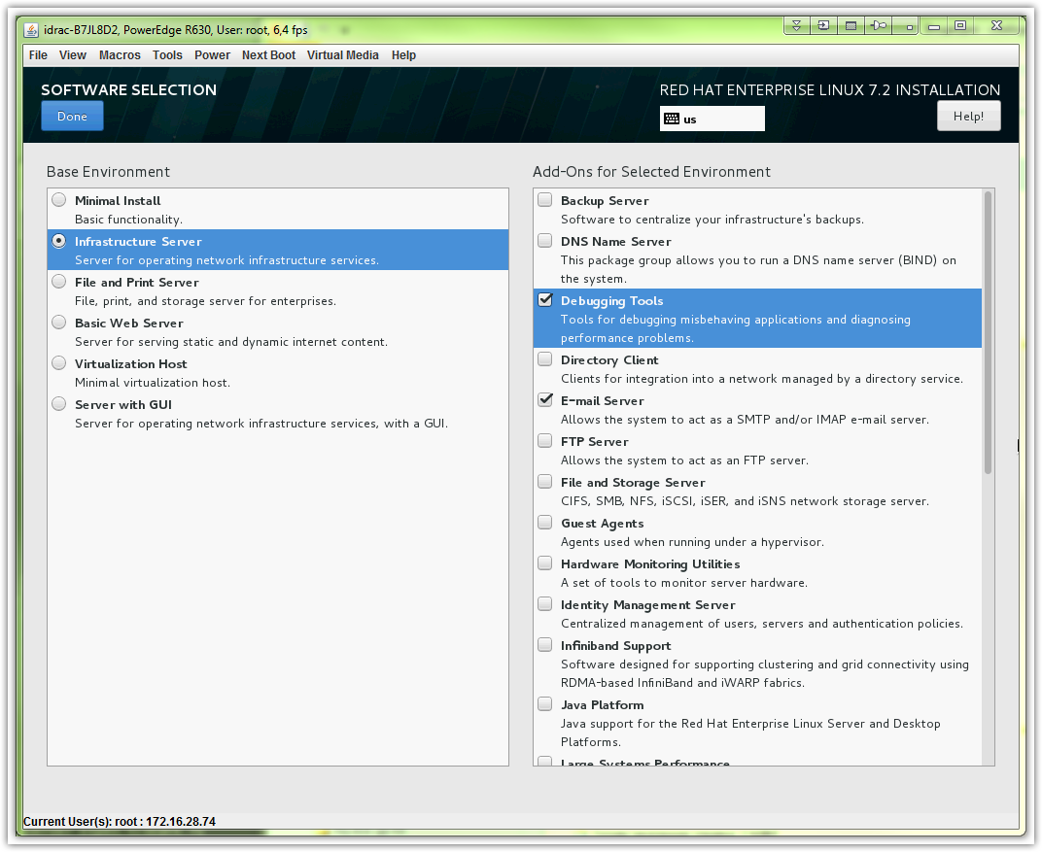

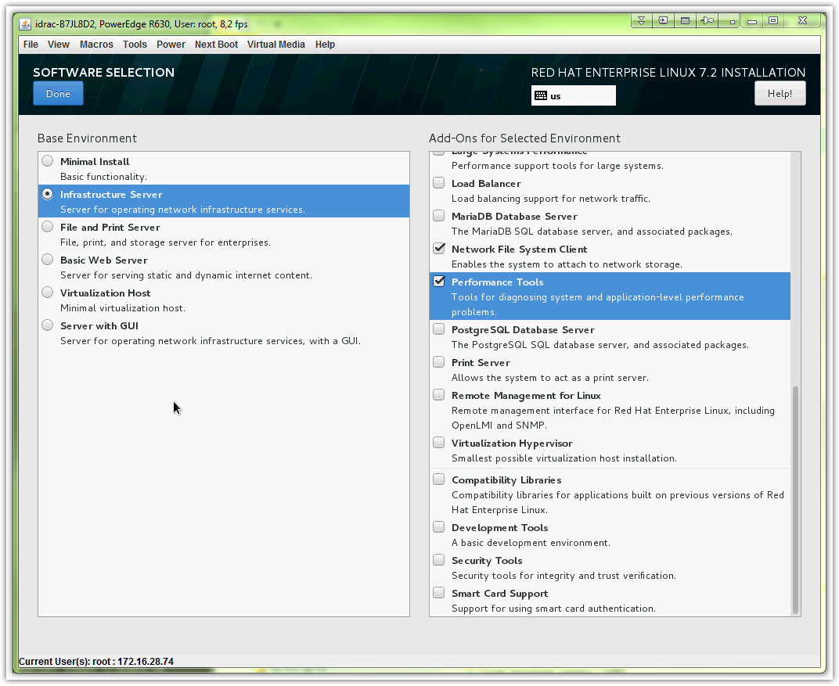
# Here is wrong ip address of dns server.
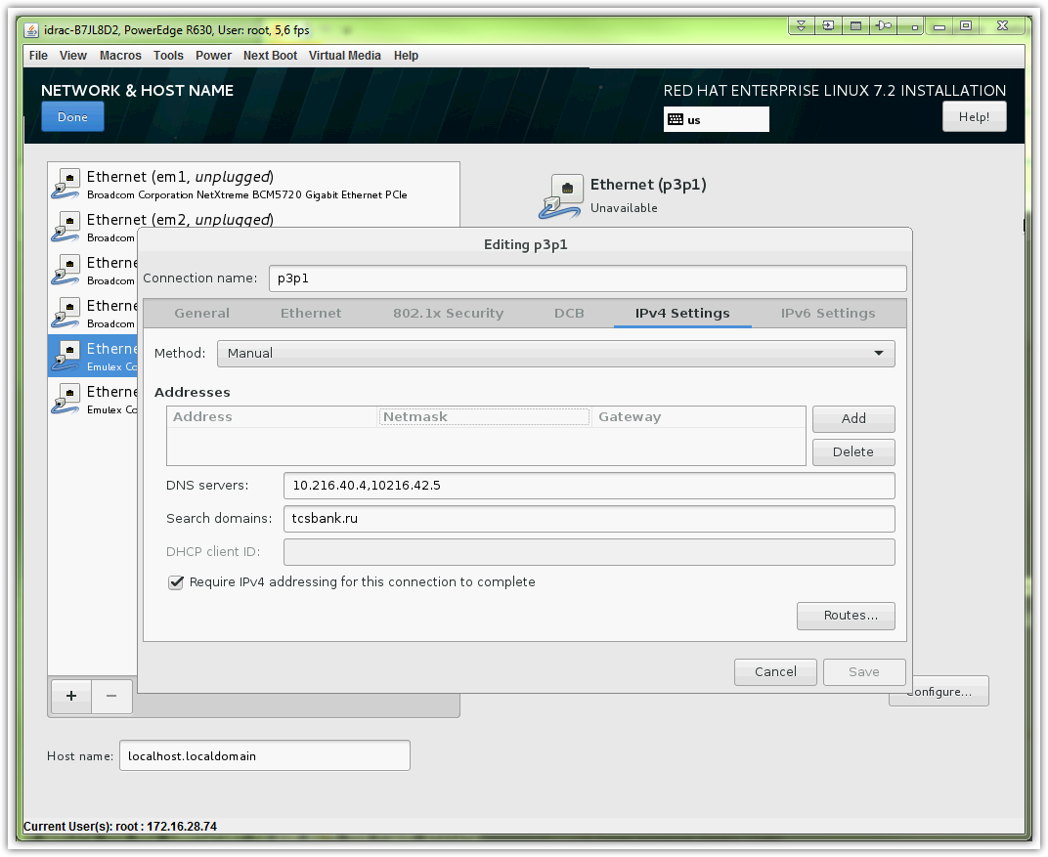
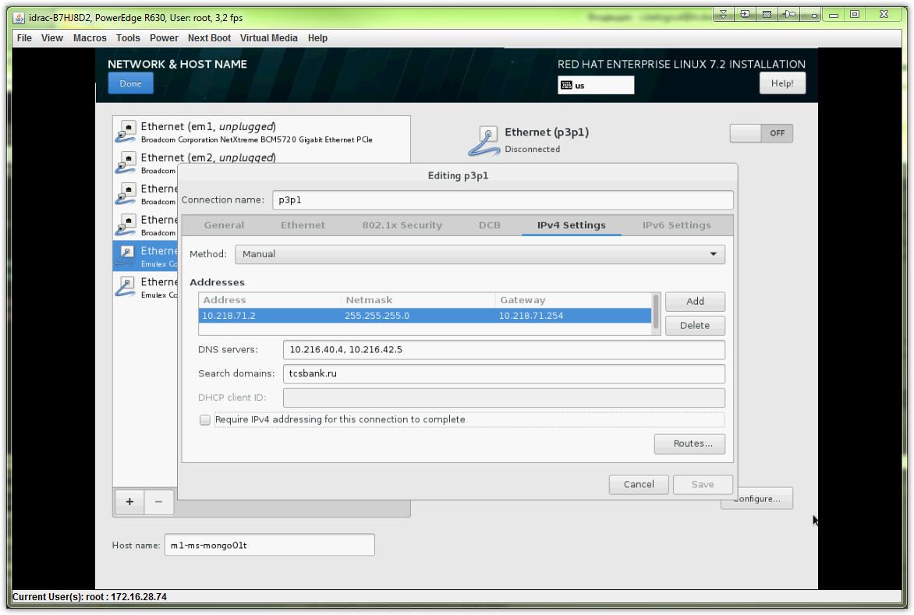

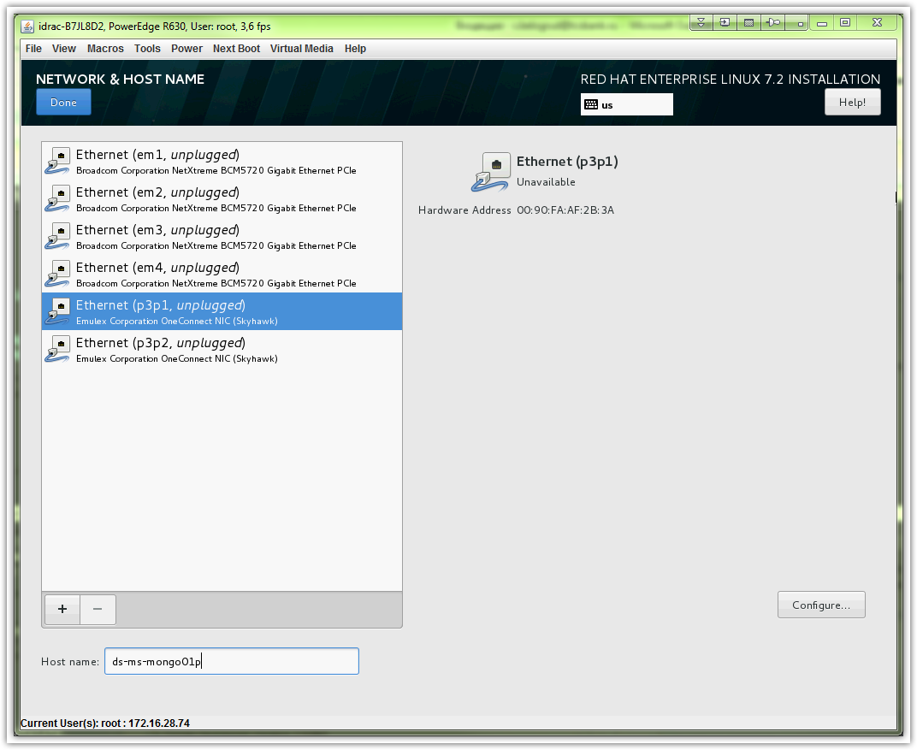

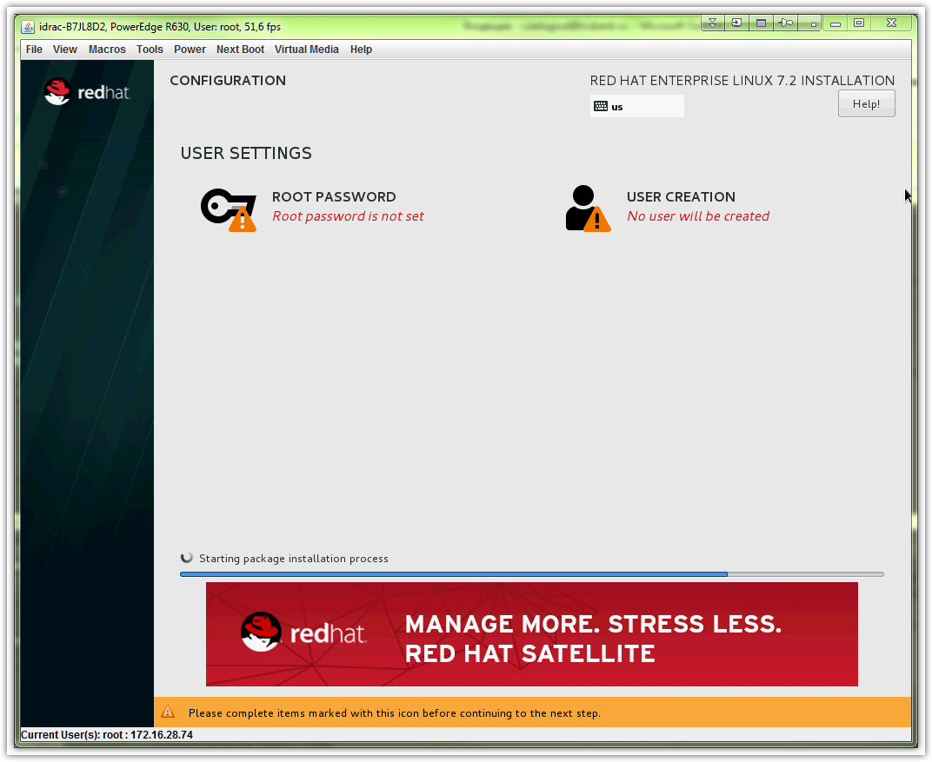

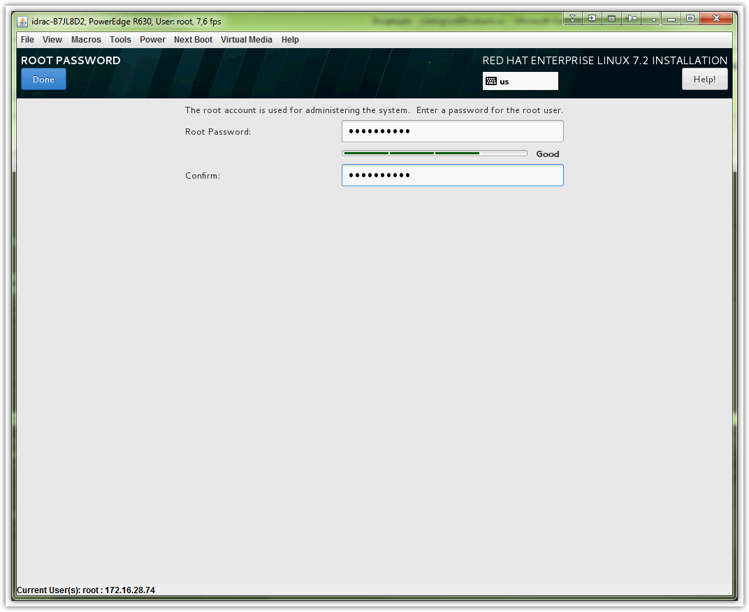

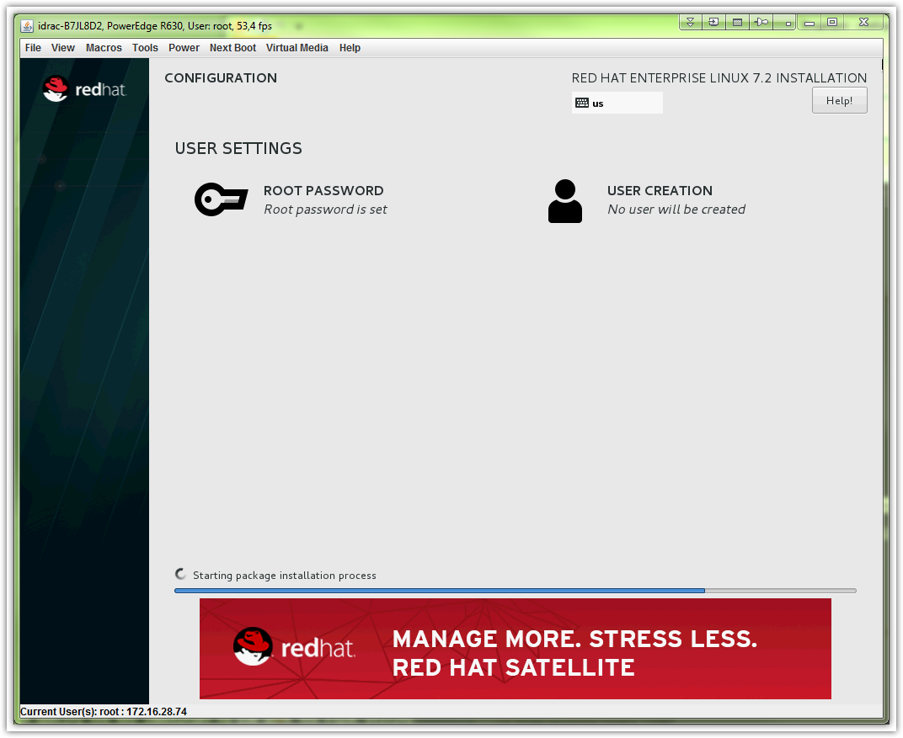

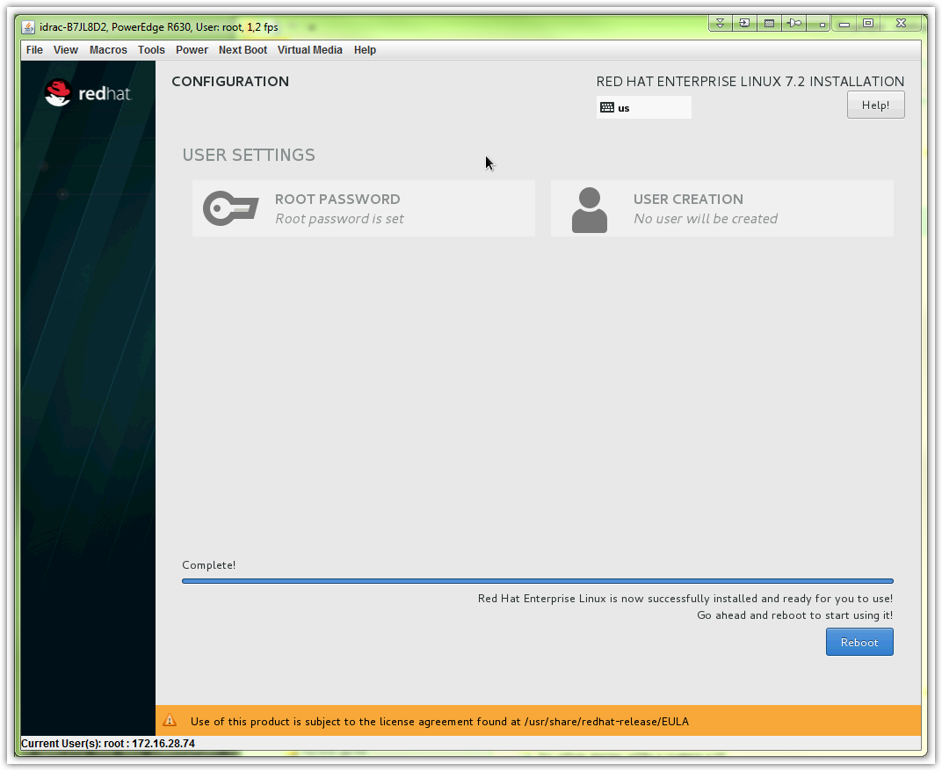

# Here is an example how to created and configure partition and filesystem and mount point for application data.

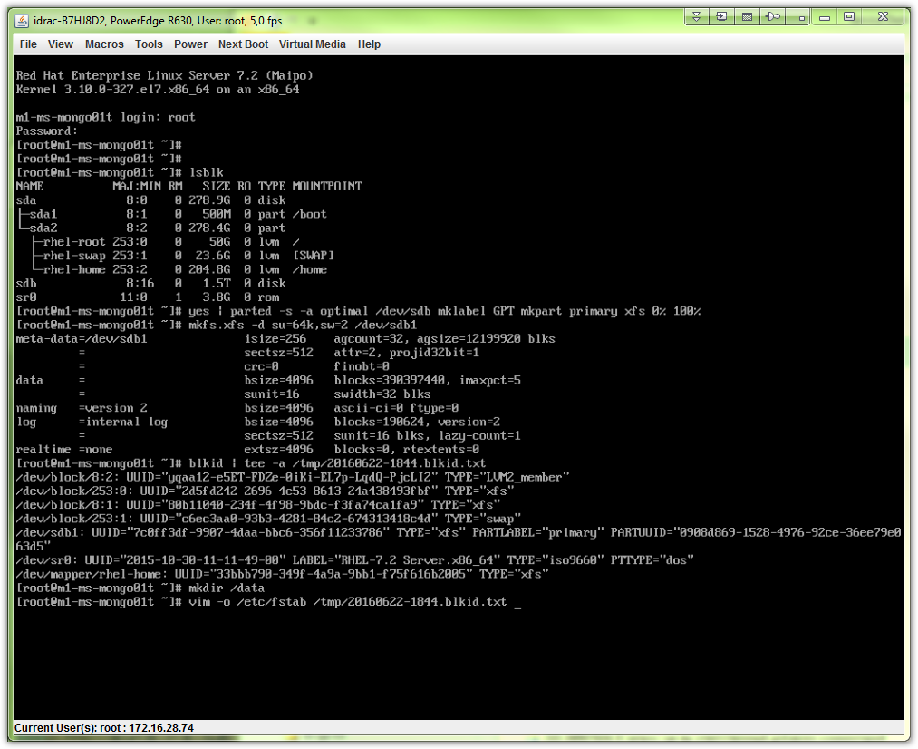

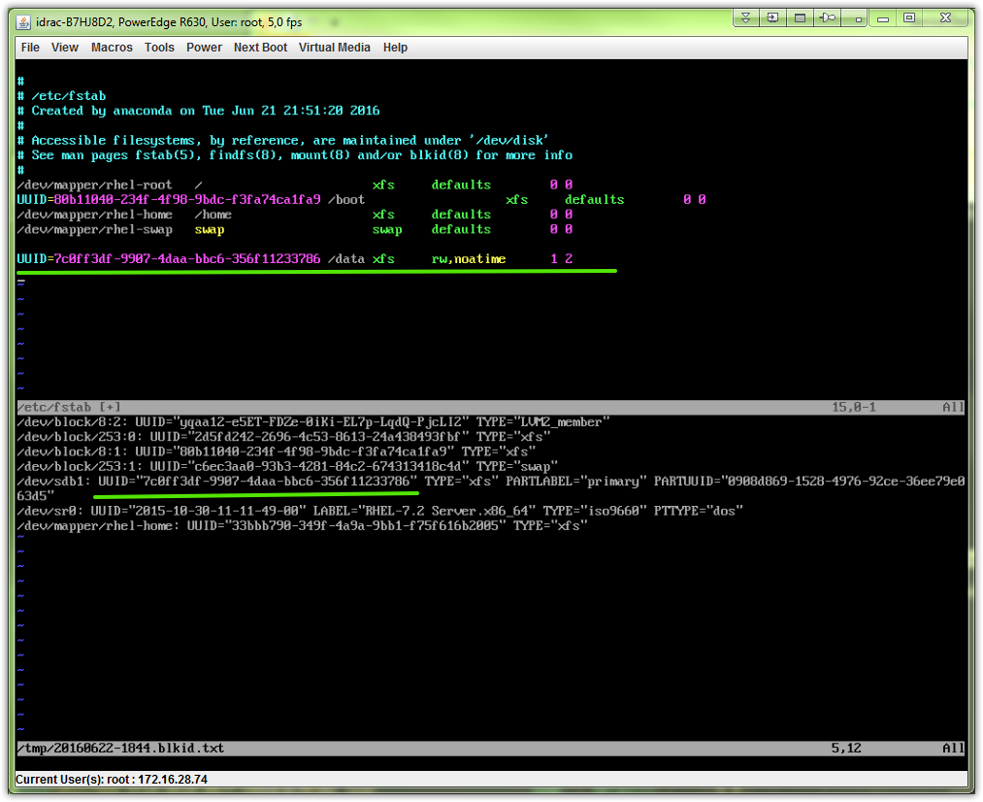

# This is my attempt to configure network after server with rhel 7.2 was installed.
# I try to use teaming instead bonding.
# And use tagged interface (vlans).
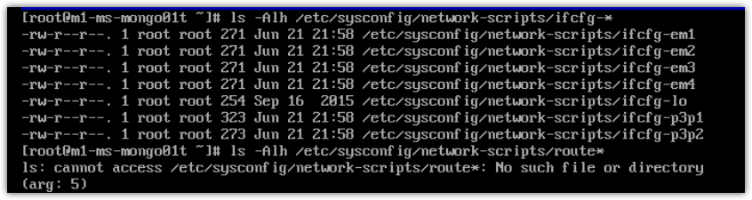
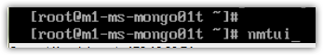
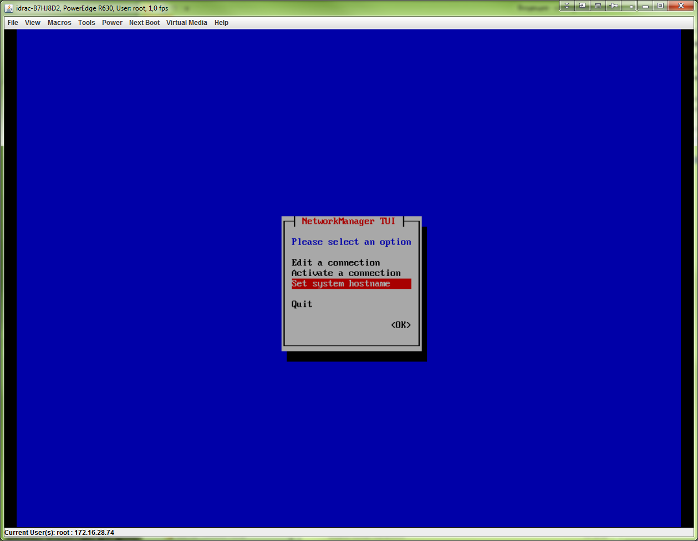

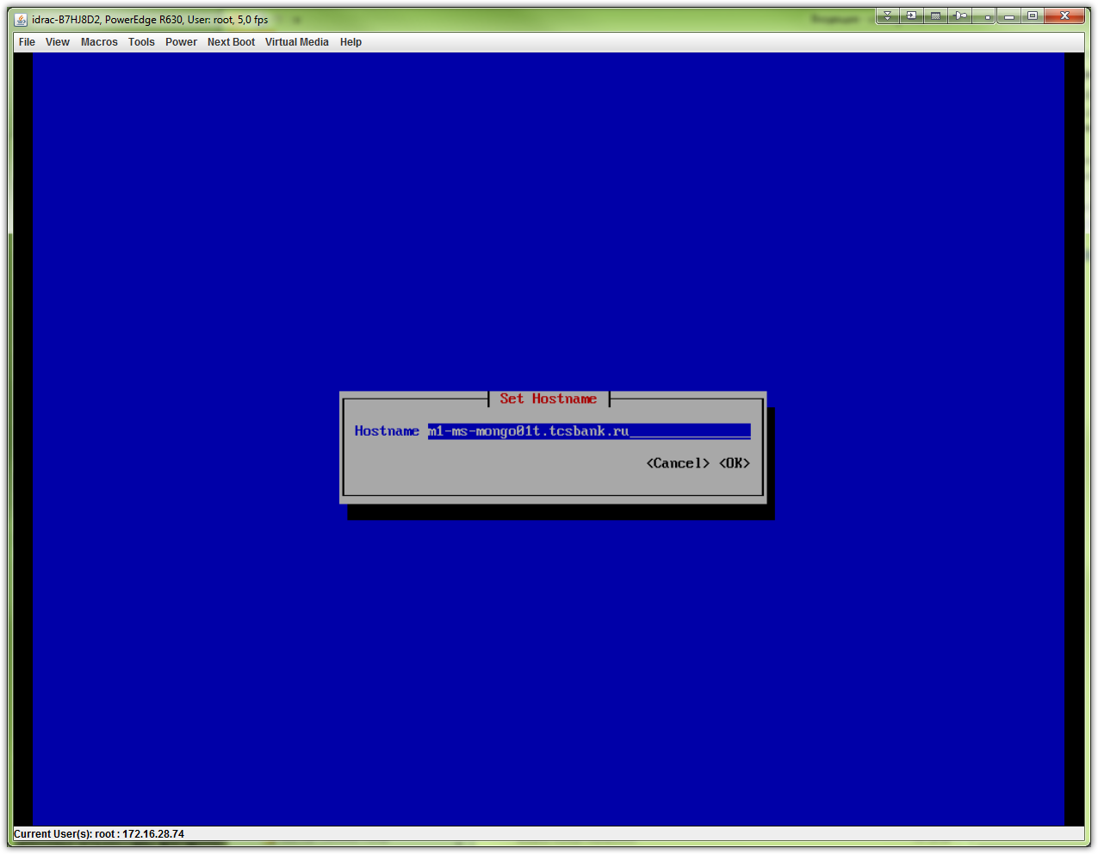

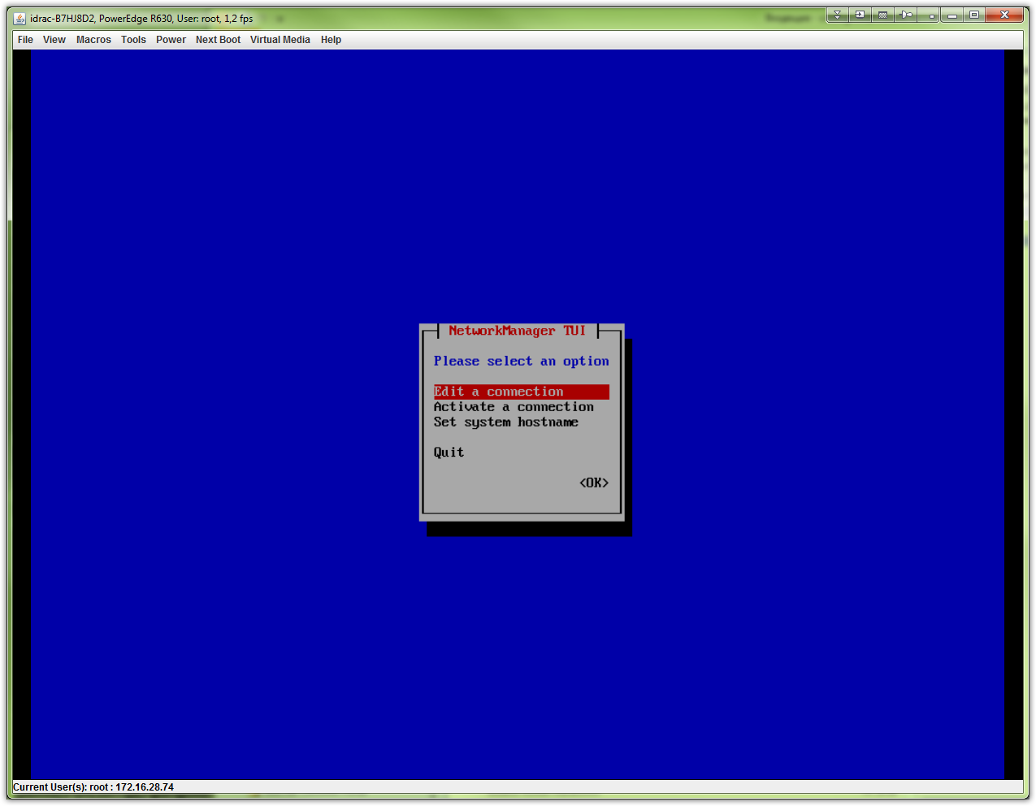
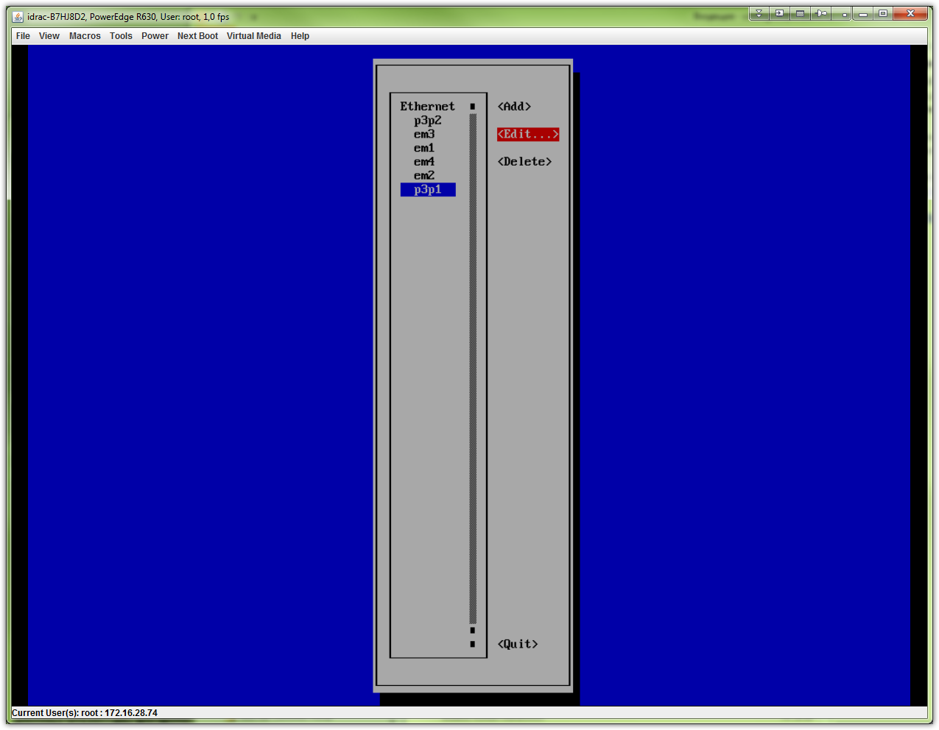
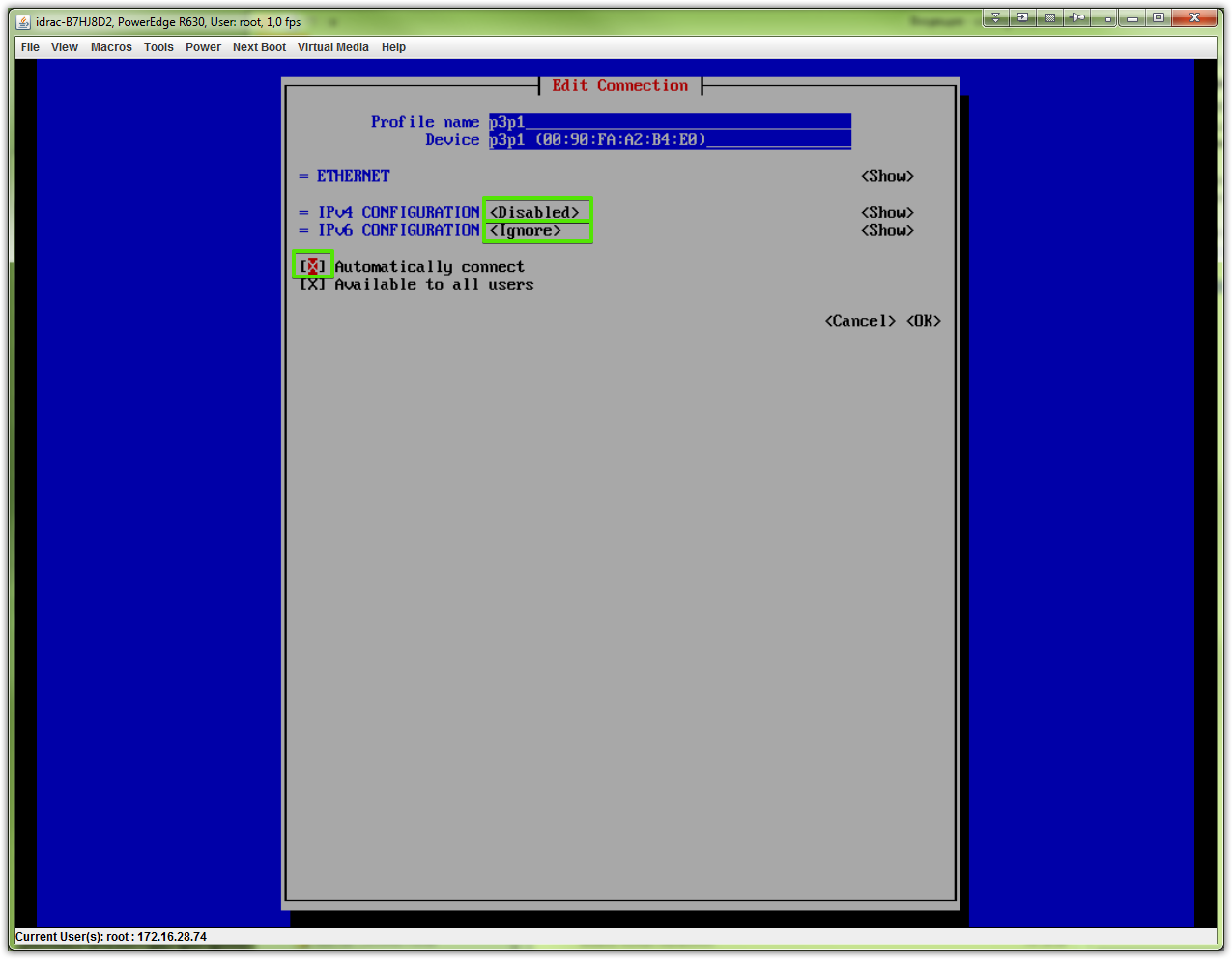
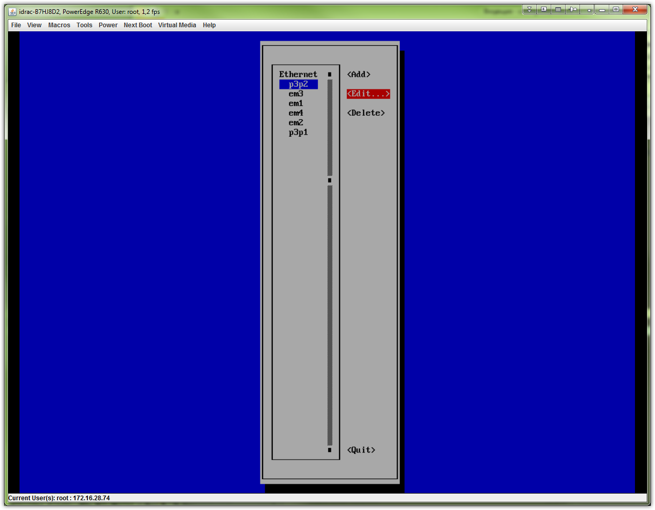
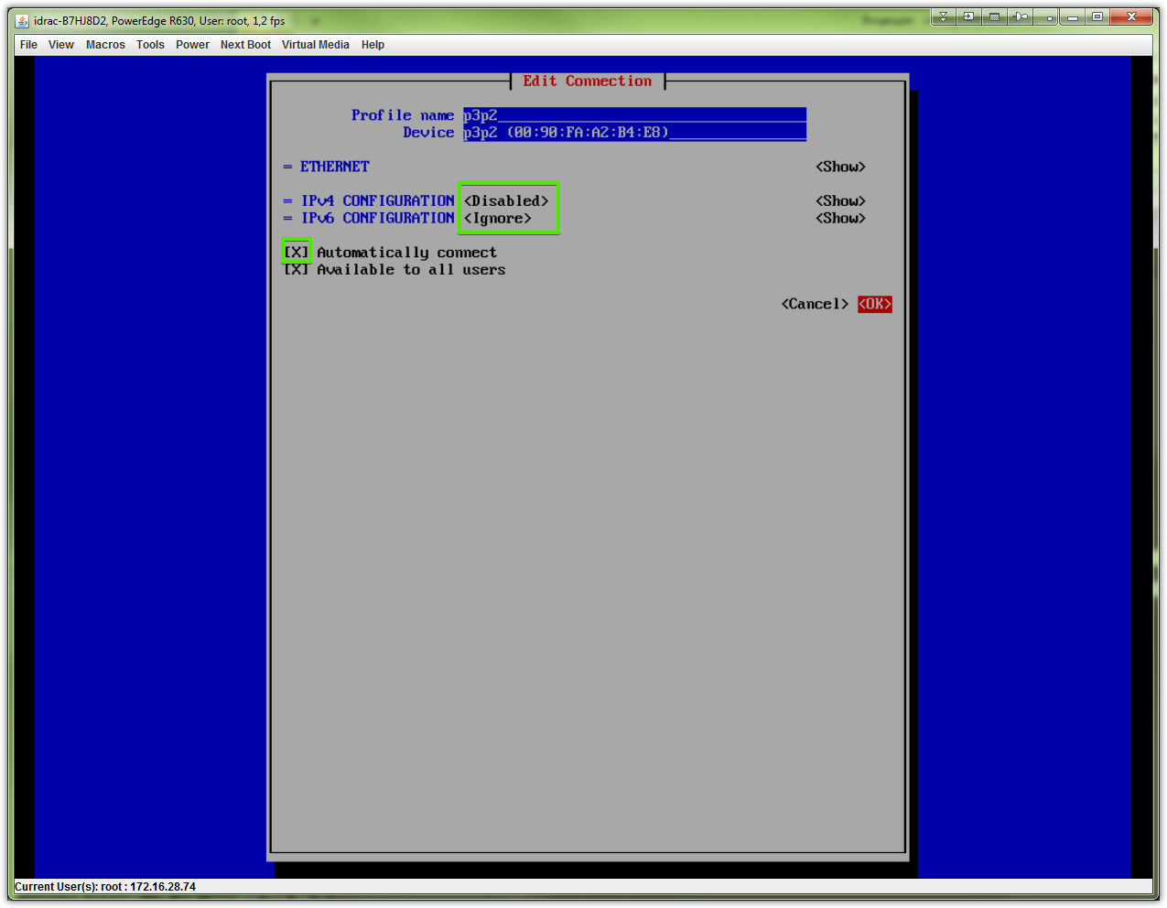

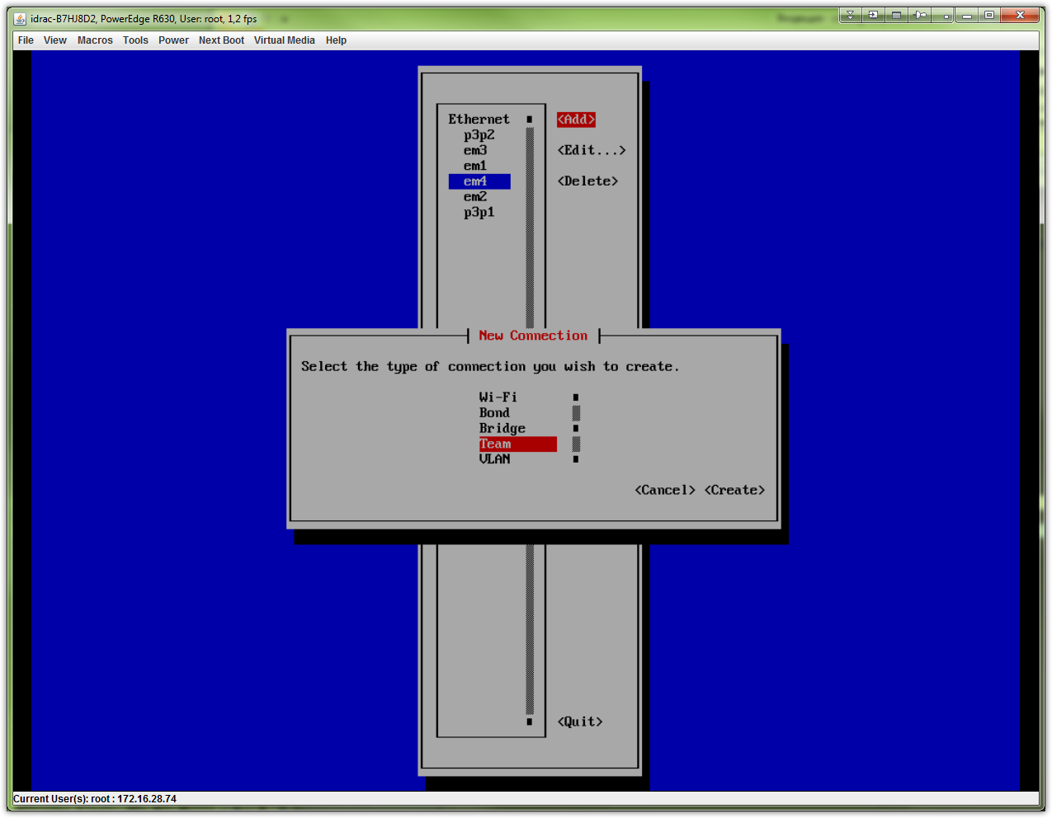
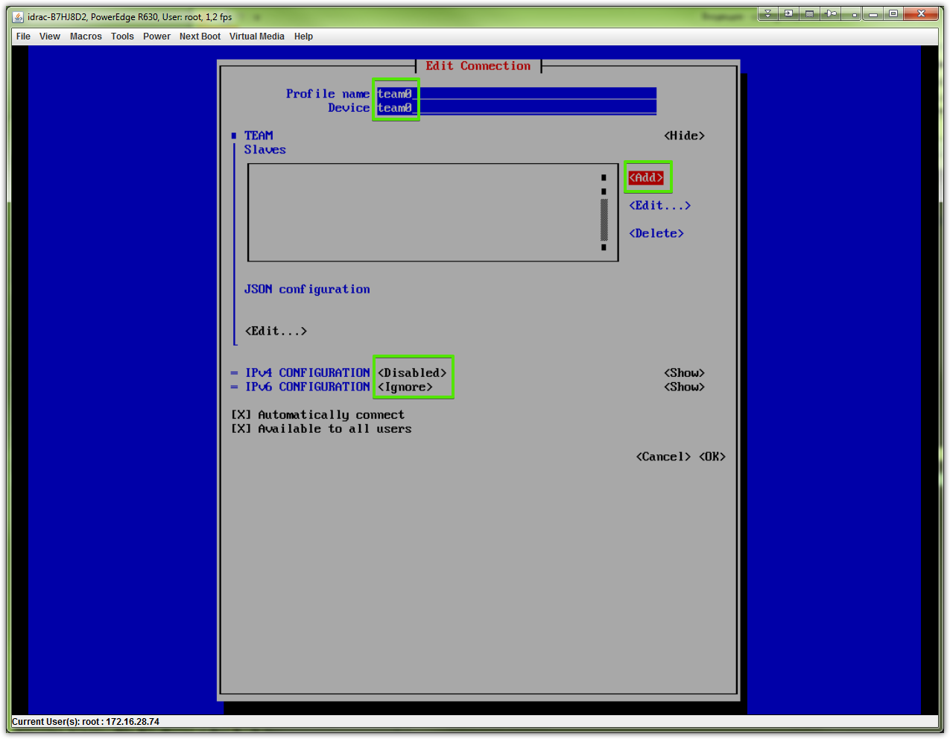

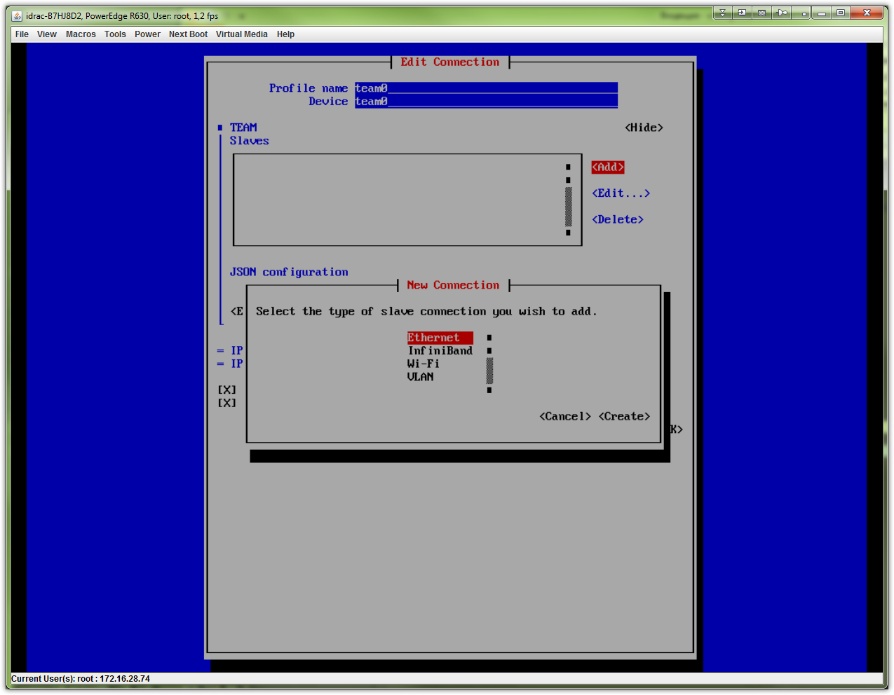

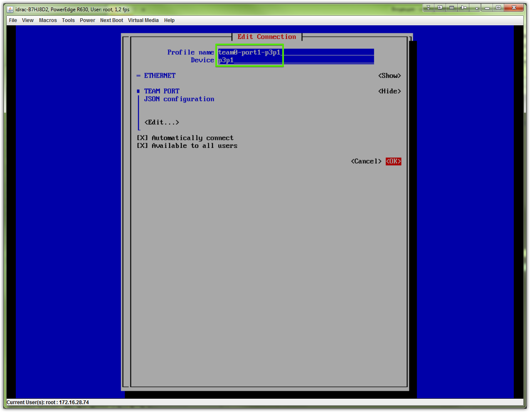
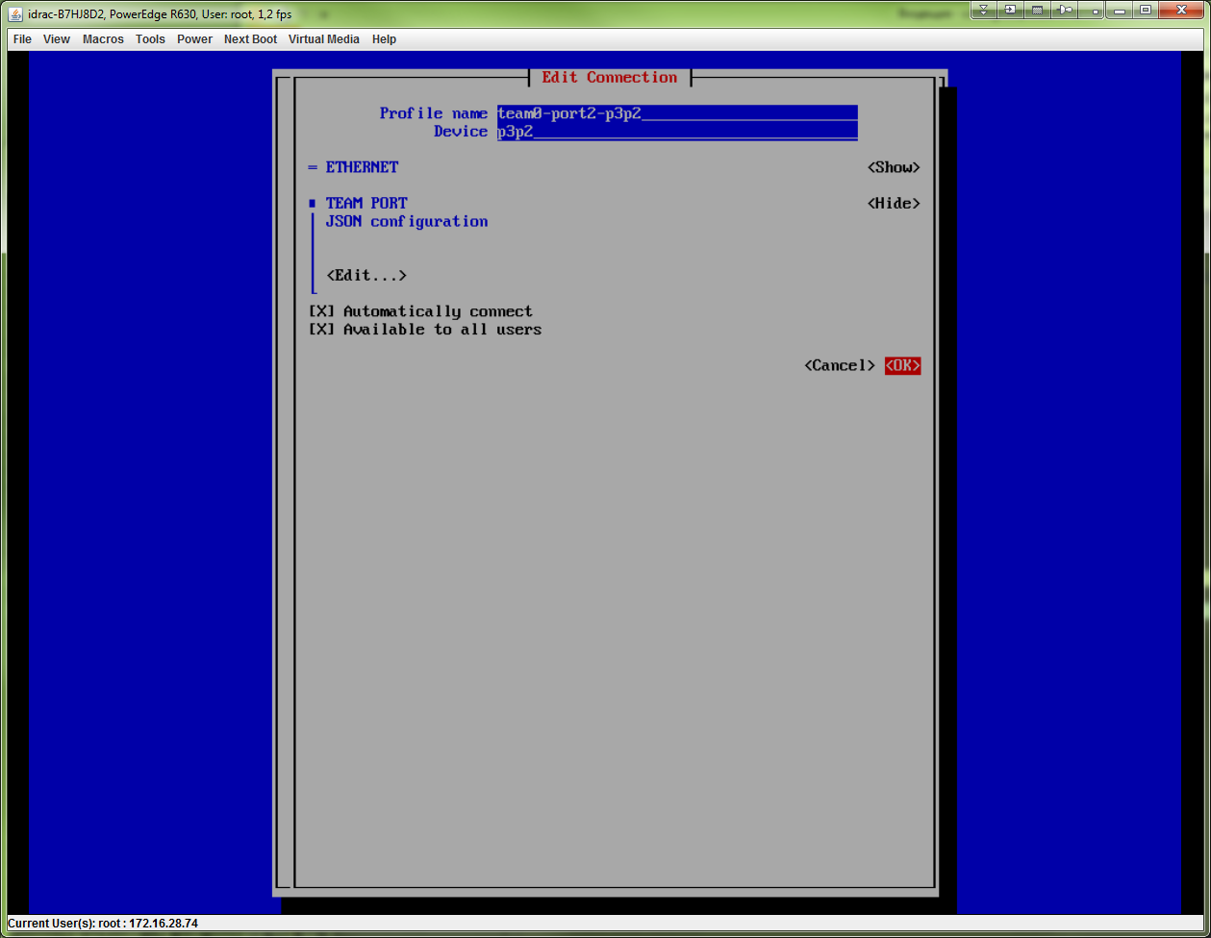

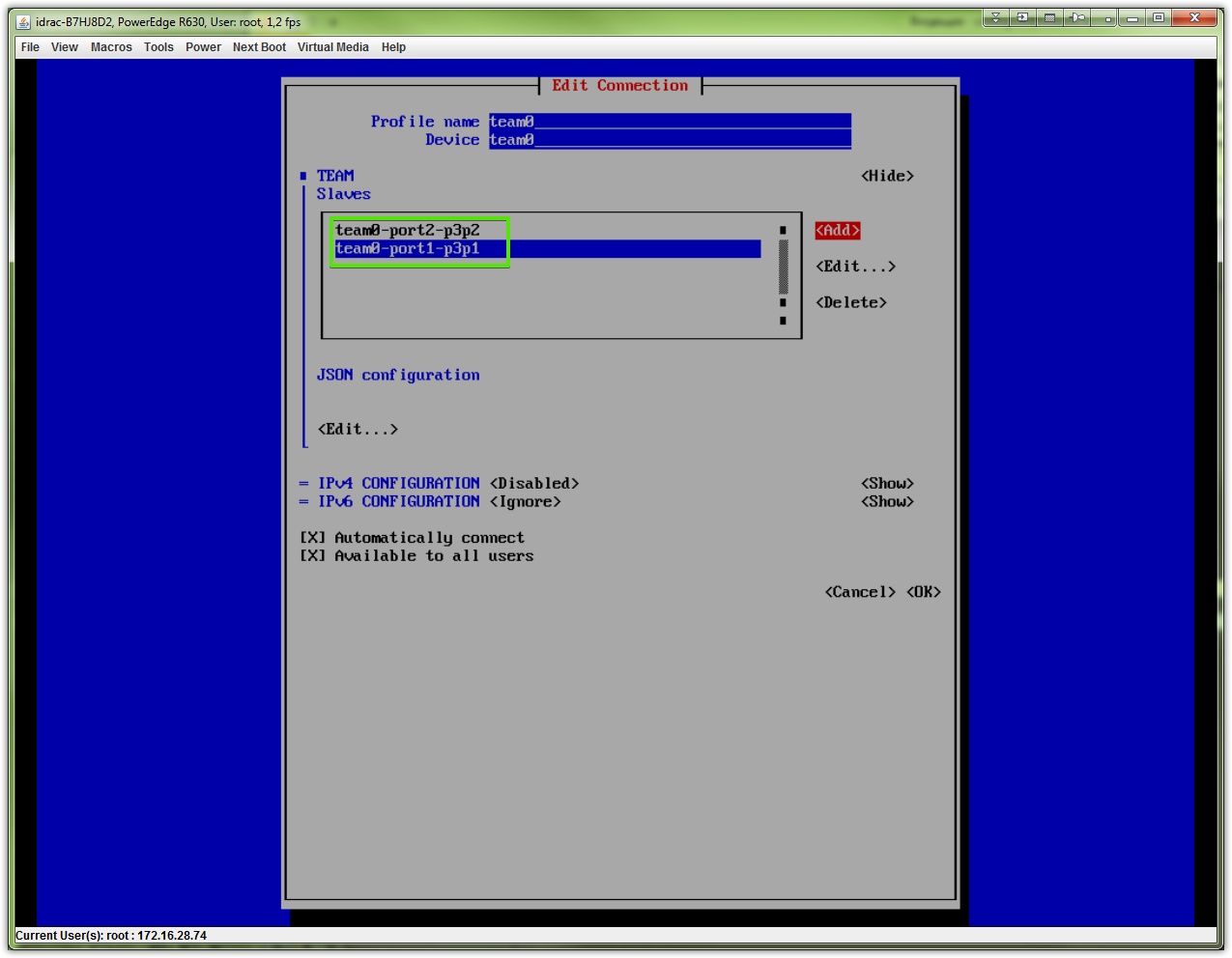

# It’s better to avoid to write “runner” statment here. I’m not sure, but this could bring me troubles, that looks like not working teaming at all. So I had reinstall OS at all.
# Better and tested way is write “runner’ string directly to file ifcfg-team0 after all interfaces will be configured with nmtui.
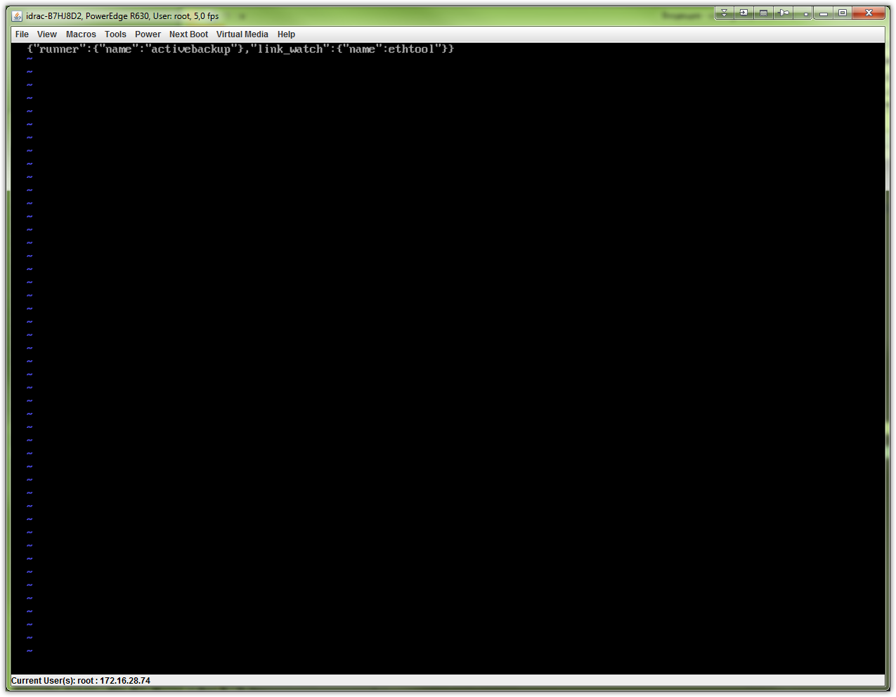

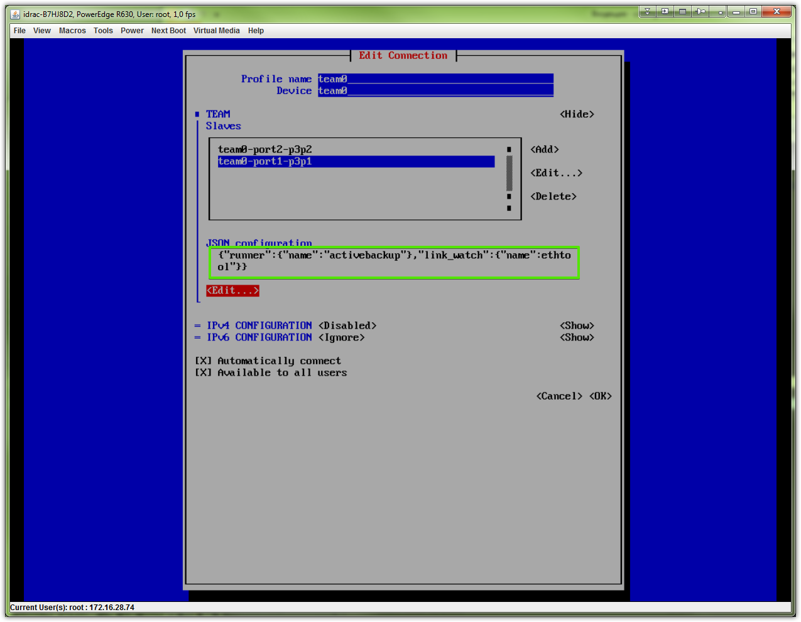
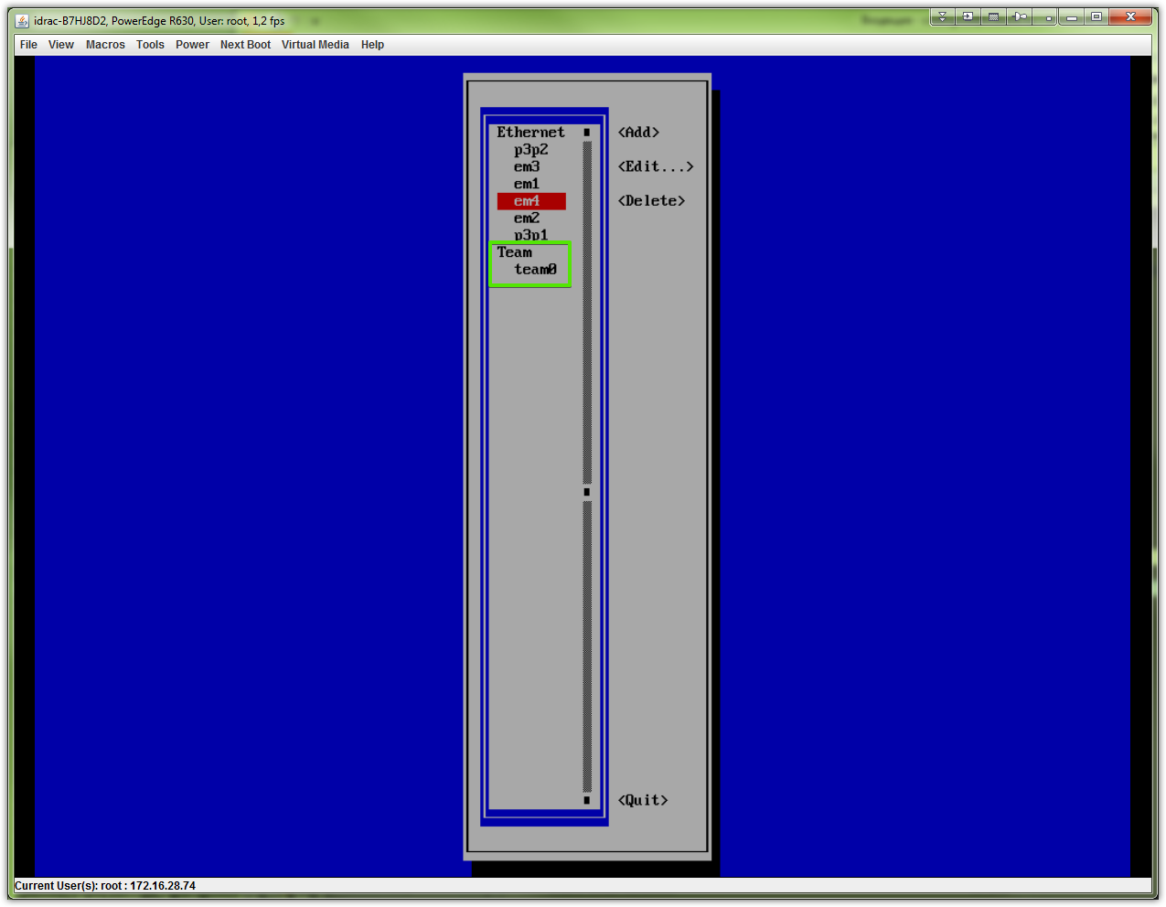

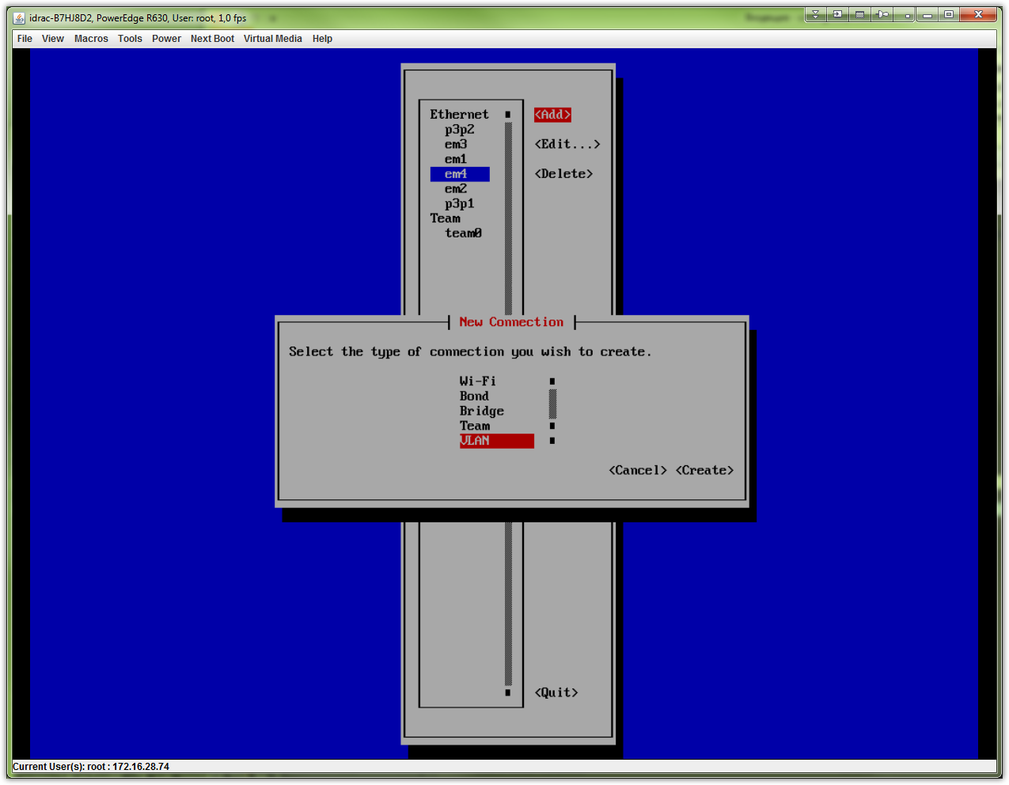

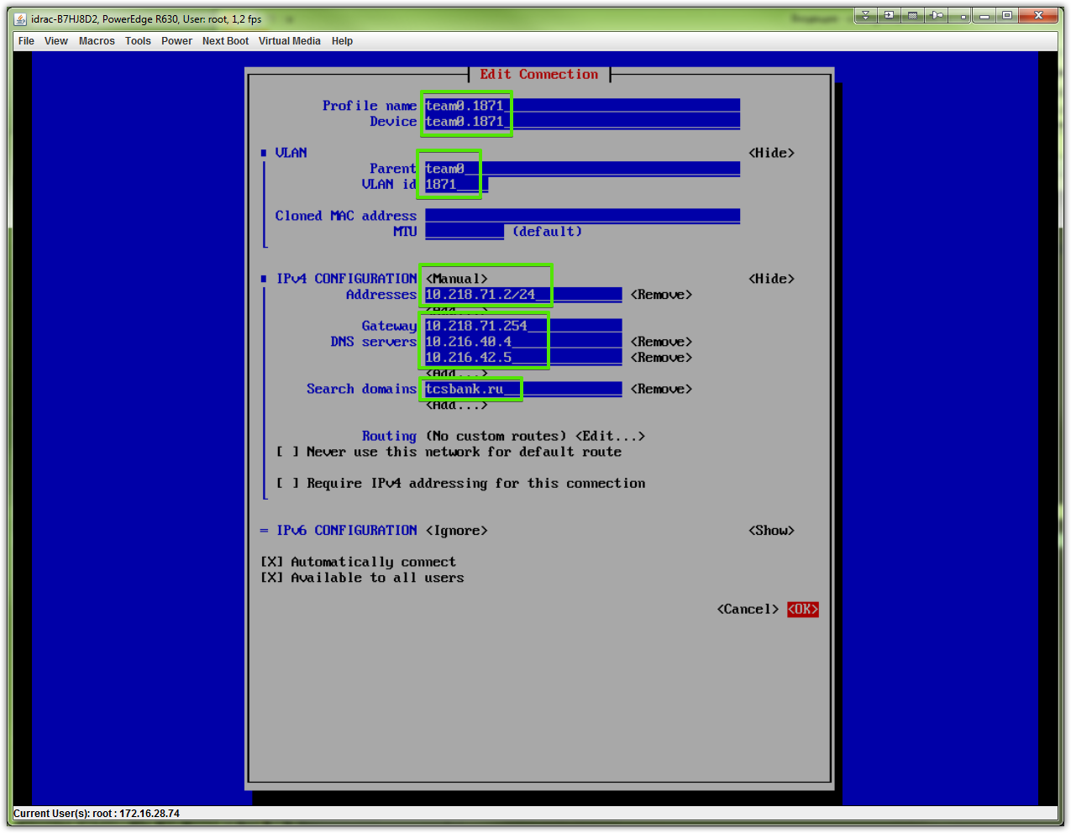
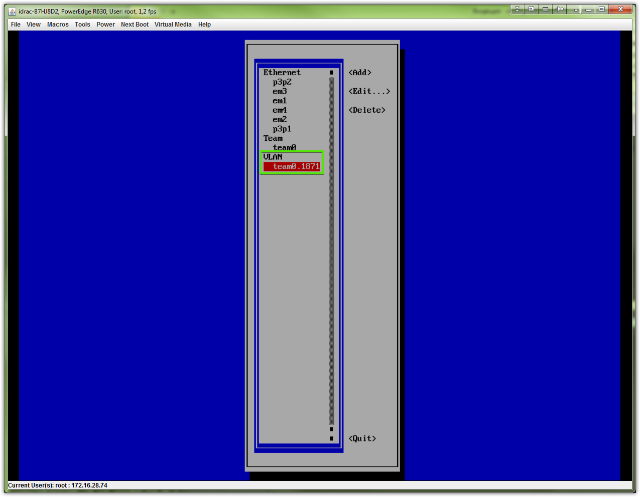
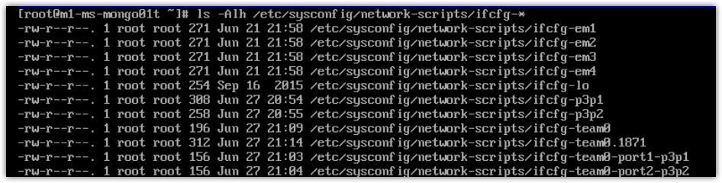

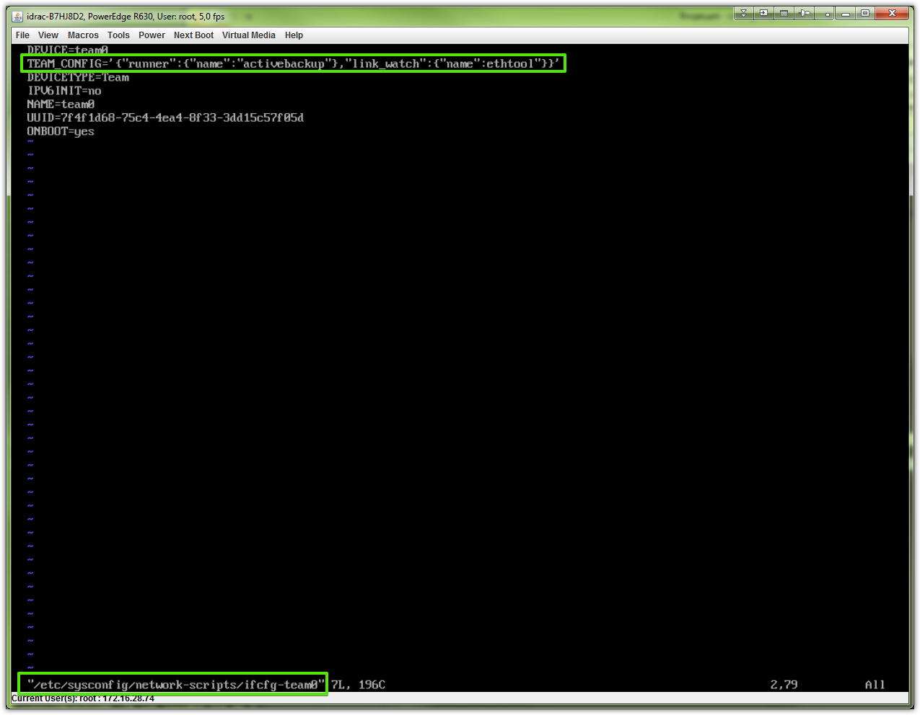
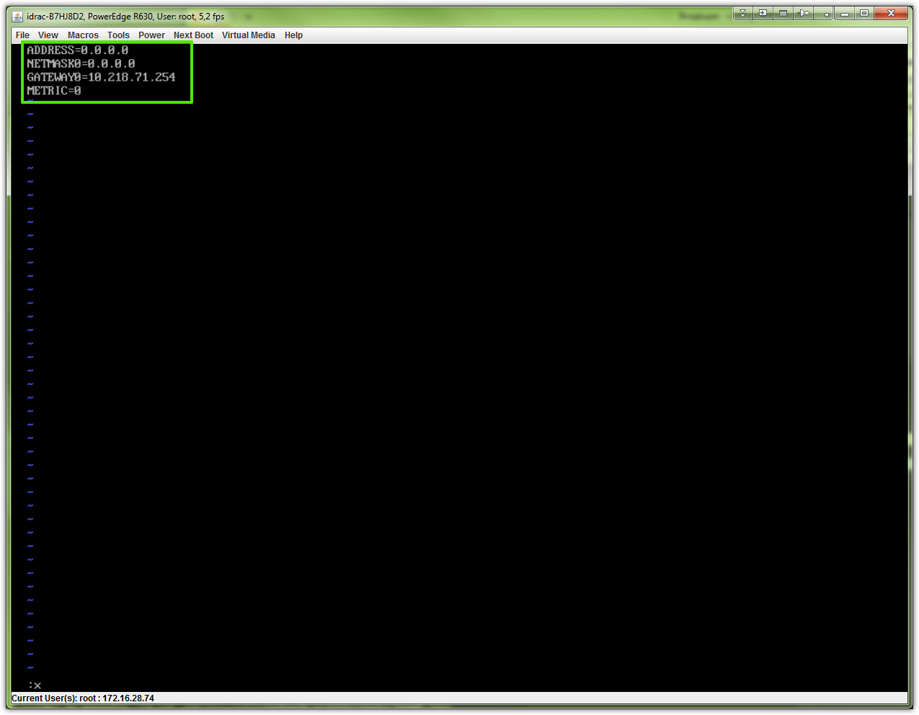
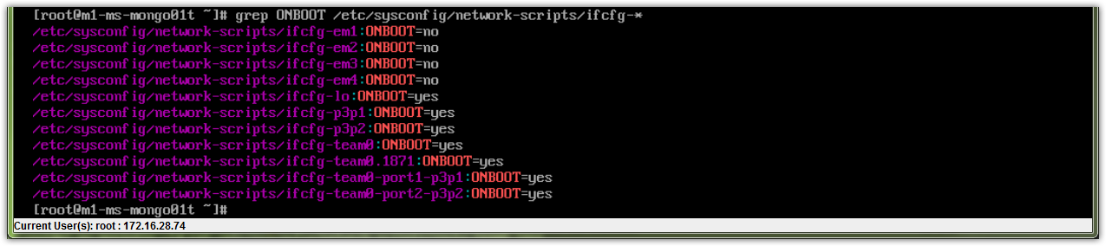

# We must start/restart all interfaces, that related with teaming - only in this case teaming start working.
# I mean interfaces “team0-port1-p3p1” and “team0-port2-p3p2” must be started/restarted!

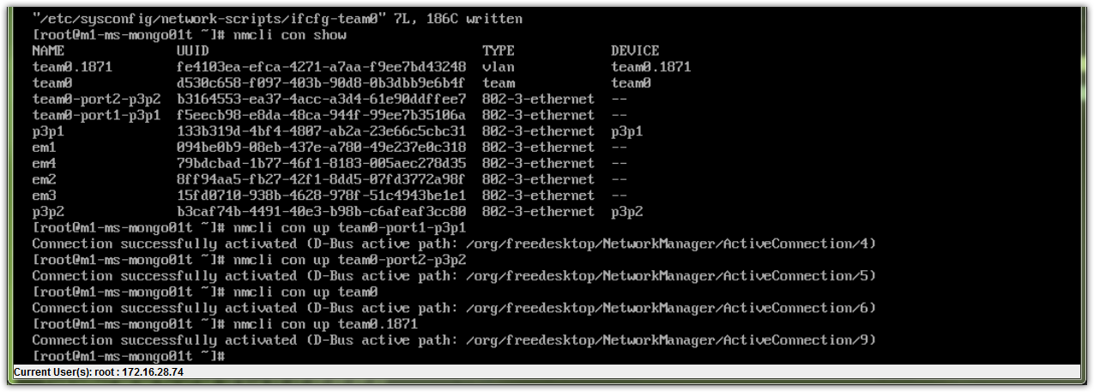
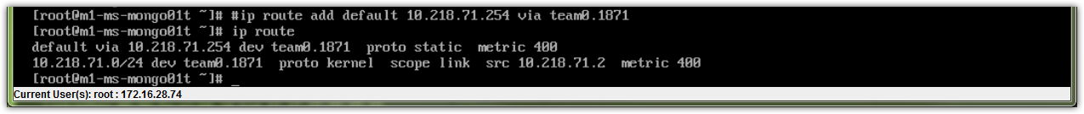
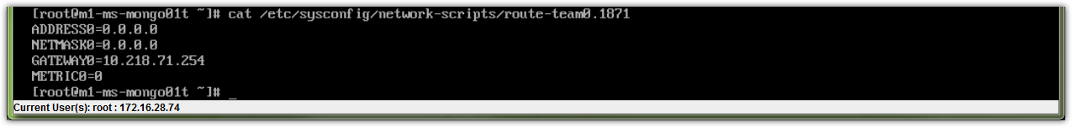

20160628
# How looks final config files.

From: Belogrud Sergey Vladimirovich
Sent: Tuesday, June 28, 2016 1:02 PM
To: Zbiranik Evgeniy Aleksandrovich
Subject: Настройка teaming.

Добрый день.

Настройка teaming.

[root@m1-ms-mongo01p ~]# ls -Alh /etc/sysconfig/network-scripts/ifcfg-*
-rw-r--r--. 1 root root 271 Jun 21 22:14 /etc/sysconfig/network-scripts/ifcfg-em1
-rw-r--r--. 1 root root 271 Jun 21 22:14 /etc/sysconfig/network-scripts/ifcfg-em2
-rw-r--r--. 1 root root 271 Jun 21 22:14 /etc/sysconfig/network-scripts/ifcfg-em3
-rw-r--r--. 1 root root 271 Jun 21 22:14 /etc/sysconfig/network-scripts/ifcfg-em4
-rw-r--r--. 1 root root 254 Sep 16 2015 /etc/sysconfig/network-scripts/ifcfg-lo
-rw-r--r--. 1 root root 257 Jun 27 19:22 /etc/sysconfig/network-scripts/ifcfg-p3p1
-rw-r--r--. 1 root root 257 Jun 27 19:22 /etc/sysconfig/network-scripts/ifcfg-p3p2
-rw-r--r--. 1 root root 186 Jun 27 19:27 /etc/sysconfig/network-scripts/ifcfg-team0
-rw-r--r--. 1 root root 312 Jun 27 19:21 /etc/sysconfig/network-scripts/ifcfg-team0.1866
-rw-r--r--. 1 root root 156 Jun 27 19:18 /etc/sysconfig/network-scripts/ifcfg-team0-port1-p3p1
-rw-r--r--. 1 root root 156 Jun 27 19:18 /etc/sysconfig/network-scripts/ifcfg-team0-port2-p3p2
[root@m1-ms-mongo01p ~]#

[root@m1-ms-mongo01p ~]# cat /etc/sysconfig/network-scripts/ifcfg-p3p1
TYPE=Ethernet
DEFROUTE=yes
PEERDNS=yes
PEERROUTES=yes
IPV4_FAILURE_FATAL=no
IPV6INIT=no
IPV6_AUTOCONF=yes
IPV6_DEFROUTE=yes
IPV6_PEERDNS=yes
IPV6_PEERROUTES=yes
IPV6_FAILURE_FATAL=no
NAME=p3p1
UUID=a72958c4-4caa-42ec-aa7b-90b04bc324af
DEVICE=p3p1
ONBOOT=no

[root@m1-ms-mongo01p ~]# cat /etc/sysconfig/network-scripts/ifcfg-p3p2
TYPE=Ethernet
DEFROUTE=yes
PEERDNS=yes
PEERROUTES=yes
IPV4_FAILURE_FATAL=no
IPV6INIT=no
IPV6_AUTOCONF=yes
IPV6_DEFROUTE=yes
IPV6_PEERDNS=yes
IPV6_PEERROUTES=yes
IPV6_FAILURE_FATAL=no
NAME=p3p2
UUID=ced3e0f4-cc55-4cf0-82b8-a38b55b31662
DEVICE=p3p2
ONBOOT=no

[root@m1-ms-mongo01p ~]# cat /etc/sysconfig/network-scripts/ifcfg-team0-port1-p3p1
NAME=team0-port1-p3p1
UUID=6e13f80a-837e-462c-a988-ff35b6987765
DEVICE=p3p1
ONBOOT=yes
TEAM_MASTER=7cdad649-1522-4465-b7ab-952702bc220e
DEVICETYPE=TeamPort
TEAM_PORT_CONFIG='{"prio":100}'

[root@m1-ms-mongo01p ~]# cat /etc/sysconfig/network-scripts/ifcfg-team0-port2-p3p2
NAME=team0-port2-p3p2
UUID=b7d2c7e6-692f-4730-90db-171f6f0f77d2
DEVICE=p3p2
ONBOOT=yes
TEAM_MASTER=7cdad649-1522-4465-b7ab-952702bc220e
DEVICETYPE=TeamPort
TEAM_PORT_CONFIG='{"prio":200}'

[root@m1-ms-mongo01p ~]# cat /etc/sysconfig/network-scripts/ifcfg-team0
DEVICE=team0
DEVICETYPE=Team
IPV6INIT=no
NAME=team0
UUID=7cdad649-1522-4465-b7ab-952702bc220e
ONBOOT=yes
TEAM_CONFIG='{"runner":{"name":"activebackup"},"link_watch":{"name":"ethtool"}}'

[root@m1-ms-mongo01p ~]# cat /etc/sysconfig/network-scripts/ifcfg-team0.1866
VLAN=yes
TYPE=Vlan
DEVICE=team0.1866
PHYSDEV=team0
VLAN_ID=1866
REORDER_HDR=0
BOOTPROTO=none
IPADDR=10.218.66.2
PREFIX=24
GATEWAY=10.218.66.254
DNS1=10.216.40.4
DNS2=10.216.42.5
DOMAIN=tcsbank.ru
DEFROUTE=yes
IPV4_FAILURE_FATAL=no
IPV6INIT=no
NAME=team0.1866
UUID=c72d2df9-8dc9-4023-8f2d-50ce26b3a852
ONBOOT=yes
[root@m1-ms-mongo01p ~]#

[root@m1-ms-mongo01p ~]# cat /etc/sysconfig/network-scripts/route-team0.1866
ADDRESS0=0.0.0.0
NETMASK0=0.0.0.0
GATEWAY0=10.218.66.254
METRIC0=0
[root@m1-ms-mongo01p ~]#

С уважением,

Сергей Белогруд
Старший системный администратор

https://linuxconfig.org/how-to-stop-start-and-disable-enable-firewall-on-redhat-7-linux-system

How to stop/start and disable/enable Firewall on Redhat 7 Linux system
Contents[Hide]
  - Stop and Start RHEL7 firewall
  - Disable and Enable RHEL7 firewall
The firewall on Redhat 7 Linux system is enabled by default. Normally there should not be a need to disable firewall but it may be quite handy for testing purposes etc. On Redhat 7 Linux system the firewall run as firewalld daemon. Bellow command can be used to check the firewall status:
[root@rhel7 ~]# systemctl status firewalld
firewalld.service - firewalld - dynamic firewall daemon
Loaded: loaded (/usr/lib/systemd/system/firewalld.service; enabled)
Active: active (running) since Thu 2014-09-04 19:18:47 EST; 3 months 28 days ago
Main PID: 539 (firewalld)
CGroup: /system.slice/firewalld.service
└─539 /usr/bin/python -Es /usr/sbin/firewalld --nofork --nopid
Sep 04 19:18:45 rhel7 systemd[1]: Starting firewalld - dynamic firewall daemon...
Sep 04 19:18:47 rhel7 systemd[1]: Started firewalld - dynamic firewall daemon.
From the above output we can see that the firewall is enabled, which means it will start automatically after reboot and that is also current active. Furthermore, or you can even check all currently applied rules with:
[root@rhel7 ~]# iptables-save

1. Stop and Start RHEL7 firewall
The firewall on Redhat 7 Linux system can be stopped by a following command:
[root@rhel7 ~]# service firewalld stop
Redirecting to /bin/systemctl stop firewalld.service
Stopped firewall will start again after system's reboot. To start firewall on Redhat 7 Linux system use:
[root@rhel7 ~]# service firewalld start
Redirecting to /bin/systemctl start firewalld.service

2. Disable and Enable RHEL7 firewall
In order to completely disable RHEL7 firewall so it would no load after reboot run:
[root@rhel7 ~]# systemctl disable firewalld
rm '/etc/systemd/system/dbus-org.fedoraproject.FirewallD1.service'
rm '/etc/systemd/system/basic.target.wants/firewalld.service'
Now the firewall would not start after system's reboot. To enable the firewall again run:
[root@rhel7 ~]# systemctl enable firewalld
ln -s '/usr/lib/systemd/system/firewalld.service' '/etc/systemd/system/dbus-org.fedoraproject.FirewallD1.service'
ln -s '/usr/lib/systemd/system/firewalld.service' '/etc/systemd/system/basic.target.wants/firewalld.service'

https://access.redhat.com/solutions/8709

How do I disable or enable the IPv6 protocol in Red Hat Enterprise Linux?
SOLUTION VERIFIED - Updated June 15 2016 at 9:47 AM -
English

Environment
- Red Hat Enterprise Linux 4
- Red Hat Enterprise Linux 5
- Red Hat Enterprise Linux 6
- Red Hat Enterprise Linux 7

Issue
- How do I disable or enable the IPv6 protocol in Red Hat Enterprise Linux?
- When I attempt to disable IPv6 in RHEL5, IPv4 does not connect. Had to re-enable IPv6 via console commands to connect to network.
- Why do I see errors when try to change IPv6 kernel parameters?
Raw
# sysctl -p
error: "net.ipv6.conf.default.accept_redirects" is an unknown key
error: "net.ipv6.conf.default.accept_ra" is an unknown key
error: "net.ipv6.conf.all.disable_ipv6" is an unknown key
error: "net.ipv6.conf.default.disable_ipv6" is an unknown key

Resolution
Red Hat Enterprise Linux enables Internet Protocol Version 6 (IPv6) by default. However, in certain situations, some users may find it desirable to disable IPv6 support or to re-enable it after it has been disabled.
For Red Hat Enterprise Linux 6, the tech brief Preparing for IPv6 Networking in Red Hat Enterprise Linux provides a broad introduction to IPv6 networking.
- Links to quickly jump to desired section below:
  - Disable IPv6 on RHEL 7
  - Re-Enable IPv6 on RHEL 7
  - Disable IPv6 on RHEL 6
  - Re-Enable IPv6 on RHEL 6
  - Disable IPv6 on RHEL 5
  - Re-Enable IPv6 on RHEL 5
  - Disable IPv6 on RHEL 4
  - Re-Enable IPv6 on RHEL 4

Disabling IPv6 support in Red Hat Enterprise Linux 7
- Disable ipv6 built-in kernel module.
- Edit /etc/default/grub and append ipv6.disable=1 to GRUB_CMDLINE_LINUX like the following sample:
- Raw
- GRUB_CMDLINE_LINUX="rd.lvm.lv=rhel/swap crashkernel=auto rd.lvm.lv=rhel/root ipv6.disable=1"
- Run the grub2-mkconfig command to regenerate the grub.cfg file:
- Raw
- # grub2-mkconfig -o /boot/grub2/grub.cfg
- Alternatively, on UEFI systems, run the following:
- Raw
- # grub2-mkconfig -o /boot/efi/EFI/redhat/grub.cfg
- Reboot the system to disable IPv6 support.
- Alternatively, this can be done via sysctl settings. Please be aware that this breaks SSH Xforwarding unless sshd_config containsAddressFamily inet.
- Create a new file named /etc/sysctl.d/ipv6.conf and add the following options:
- Raw
- # To disable for all interfaces
net.ipv6.conf.all.disable_ipv6 = 1
# the protocol can be disabled for specific interfaces as well.
net.ipv6.conf.<interface>.disable_ipv6 = 1
- The new settings would then need to be reloaded with:
- Raw
- # sysctl -p /etc/sysctl.d/ipv6.conf

Re-enabling IPv6 support in Red Hat Enterprise Linux 7
- Edit /etc/default/grub and delete the entry ipv6.disable=1 from the GRUB_CMDLINE_LINUX, like the following sample:
- Raw
- GRUB_CMDLINE_LINUX="rd.lvm.lv=rhel/swap crashkernel=auto rd.lvm.lv=rhel/root"
- Run the grub2-mkconfig command to regenerate the grub.cfg file:
- Raw
- # grub2-mkconfig -o /boot/grub2/grub.cfg
- Alternatively, on UEFI systems, run the following:
- Raw
- # grub2-mkconfig -o /boot/efi/EFI/redhat/grub.cfg
- Delete the file /etc/sysctl.d/ipv6.conf which contains the entry:
- Raw
- # To disable for all interfaces
net.ipv6.conf.all.disable_ipv6 = 1
# the protocol can be disabled for specific interfaces as well.
net.ipv6.conf.<interface>.disable_ipv6 = 1
- Check the content of the file /etc/ssh/sshd_config and make sure the AddressFamily line is commented:
- Raw
- #AddressFamily inet
- Make sure the following line exists in /etc/hosts, and is not commented out:
- Raw
- ::1 localhost localhost.localdomain localhost6 localhost6.localdomain6
- Reboot the system to enable IPv6 support.

Disabling IPv6 support in Red Hat Enterprise Linux 6
- Create a file /etc/modprobe.d/ipv6.conf with the following contents:
- Raw
- options ipv6 disable=1
- Disable the ip6tables service from starting at boot by issuing the following command:
- Raw
- # chkconfig ip6tables off
- Alternatively, the IPv6 support can also be disabled in the kernel through /etc/sysctl.conf by setting following parameter:
- Raw
- # IPv6 support in the kernel, set to 0 by default
net.ipv6.conf.all.disable_ipv6 = 1
net.ipv6.conf.default.disable_ipv6 = 1
- Please be aware that this breaks SSH Xforwarding unless AddressFamily inet is set in sshd_config.
- Comment out any IPv6 addresses found in /etc/hosts, including ::1 localhost address
- Raw
- # cp -p /etc/hosts /etc/hosts.disableipv6
# sed -i 's/^[[:space:]]*::/#::/' /etc/hosts
- Optionally to prevent rpc.nfsd setting up IPv6 sockets while NFS server is running, edit /etc/netconfig for the lines starting with udp6 and tcp6; change the "v" in the third column to "-"(hyphen/dash)
- Reboot the system to disable IPv6 support.
Note: The solution above only disables (unhooks all of the calls) the ipv6 module, but doesn't prevent it from loading. Unloading the module isn't recommended due to the dependency factors it has with other modules (for example: bonding) and services. To prevent the module from loading, modify/etc/modprobe.d/ipv6.conf with the following contents:
Raw
install ipv6 /bin/true
- Disabling ipv6 in the sysctl.conf will ensure ipv6 isn't used even if the ipv6 module is loaded and can work as a short term solution (until a full reboot)
- There is a special case where this might not work, please see The "ipv6 disable=1" option does not seem to work on Red Hat Enterprise Linux 6 system.

Re-enabling IPv6 support in Red Hat Enterprise Linux 6
- Review the files under /etc/modprobe.d/ and remove (or comment out) any of the following lines:
- Raw
- options ipv6 disable=1
install ipv6 /bin/true
blacklist ipv6
alias ipv6 off
- Configure the ip6tables service to start at boot by issuing the following command:
- Raw
- # chkconfig ip6tables on
- Make sure the following options to your /etc/sysctl.conf are set to default value '0'
- Raw
- # ipv6 support in the kernel, set to 0 by default
net.ipv6.conf.all.disable_ipv6 = 0
net.ipv6.conf.default.disable_ipv6 = 0
- Make sure the following line exists in /etc/hosts and is not commented out:
- Raw
- ::1 localhost localhost.localdomain localhost6 localhost6.localdomain6
- Edit /etc/netconfig for the lines starting with udp6 and tcp6; change the "-"(hyphen/dash) in the third column to "v"
- Reboot the system to activate IPv6 support.

Disabling IPv6 support in Red Hat Enterprise Linux 5
- Remove the following line (if present) from the /etc/modprobe.conf file:
- Raw
- alias net-pf-10 ipv6
- Add the following line to the /etc/modprobe.conf file:
- Raw
- alias net-pf-10 off
- In versions of Red Hat Enterprise Linux before 5.4, add the following line to the /etc/modprobe.conf file:
- Raw
- alias ipv6 off
- In Red Hat Enterprise Linux 5.4 and later, add the following line to the /etc/modprobe.conf file:
- Raw
- options ipv6 disable=1
- To prevent errors during the network initscript start routine, change the NETWORKING_IPV6 parameter in the /etc/sysconfig/network file to the following:
- Raw
- NETWORKING_IPV6=no
- Comment out any IPv6 addresses found in /etc/hosts, including ::1 localhost address
- Raw
- # cp -p /etc/hosts /etc/hosts.disableipv6
# sed -i 's/^[[:space:]]*::/#::/' /etc/hosts
- Disable the ip6tables service from starting at boot by issuing the following command:
- Raw
- # chkconfig ip6tables off
- Reboot the system to disable IPv6 support.

Re-enabling IPv6 support in Red Hat Enterprise Linux 5
- Remove the following lines (if present) from the /etc/modprobe.conf file:
- Raw
- alias net-pf-10 off
alias ipv6 off
options ipv6 disable=1
- Add the following line to the /etc/modprobe.conf file (if not present already):
- Raw
- alias net-pf-10 ipv6
- Change the NETWORKING_IPV6 parameter in the /etc/sysconfig/network file to the following:
- Raw
- NETWORKING_IPV6=yes
- Make sure the following line exists in /etc/hosts and is not commented out:
- Raw
- ::1 localhost localhost.localdomain localhost6 localhost6.localdomain6
- Configure the ip6tables service to start at boot by issuing the following command:
- Raw
- # chkconfig ip6tables on
- Reboot the system to re-enable IPv6 support.

Disabling IPv6 support in Red Hat Enterprise Linux 4
- Remove the following line (if present) from the /etc/modprobe.conf file:
- Raw
- alias net-pf-10 ipv6
- Add the following line to the /etc/modprobe.conf file:
- Raw
- alias net-pf-10 off
- Comment out any IPv6 addresses found in /etc/hosts, including ::1 localhost address
- Raw
- # cp -p /etc/hosts /etc/hosts.disableipv6
# sed -i 's/^[[:space:]]*::/#::/' /etc/hosts
- Reboot the system to disable IPv6 support.

Re-enabling IPv6 support in Red Hat Enterprise Linux 4
- Remove the following line from the /etc/modprobe.conf file:
- Raw
- alias net-pf-10 off
- Add the following line to the /etc/modprobe.conf file:
- Raw
- alias net-pf-10 ipv6
- Make sure the following line exists in /etc/hosts, and is not commented out.
- Raw
- ::1 localhost localhost.localdomain localhost6 localhost6.localdomain6
- Reboot the system to re-enable IPv6 support.

Additional notes
Disabling IPv6 by blacklisting the module invalidates bonding in the system.

https://access.redhat.com/solutions/65300

How to access Red Hat Subscription Manager (RHSM) through a firewall/proxy
SOLUTION VERIFIED - Updated Friday at 12:58 PM -
English

Environment
- Red Hat Enterprise Linux 7 (and later)
- Red Hat Enterprise Linux 6.1 (and later)
- Red Hat Enterprise Linux 5.8 (and later)
- Red Hat Subscription Management (RHSM)
- Red Hat Satellite 6

Issue
- How do I configure my system so that yum can access Red Hat Subscription Management (RHSM) through a firewall or proxy?
- What URLs and ports do I need to configure in my proxy server to access RHSM?
- How do I access RHSM (yum) through a firewall?
- Not able to register due to network error
- Red Hat Satellite 6 is unable to sync content from Red Hat. I suspect it is the company firewall blocking the traffic. What hostnames do I need to give to the network security team to allow content syncing?
- Our network team says they need IP addresses to enable them to allow our Red Hat Satellite 6 installation to talk to the Content Delivery Network. We can not use hostnames and must use IP address or ranges.

Resolution
It is necessary to allow the following hostnames/ports on the outgoing network firewall to have a fully working yum + subscription-manager or content syncing to Red Hat Satellite 6:
- subscription.rhn.redhat.com:443 [https]
- cdn.redhat.com:443 [https]
- *.akamaiedge.net:443 [https] OR *.akamaitechnologies.com:443 [https]
It is not recommended to specify the IP addresses because the packages are distributed through the Akamai network and the IP addresses may be subject to change. However, if your firewall is unable to use hostname filtering, Red Hat provides a pool of IP addresses that should provide CDN delivery.
Note: If the system is behind http proxy, add the details in /etc/rhsm/rhsm.conf below:
Raw
# an http proxy server to use (enter server FQDN)
proxy_hostname =
# port for http proxy server
proxy_port =
# user name for authenticating to an http proxy, if needed
proxy_user =
# password for basic http proxy auth, if needed
proxy_password =

Root Cause
- Firewall or proxy is not configured for access to RHSM.
- Some firewalls or organizations can not use hostnames and might need more granular control.

Diagnostic Steps

Some example of errors seen when Subscription-Manager was not able to access the above URLs due to firewall and/or proxies
- Seeing this error (in /var/log/rhsm/rhsm.log) when trying to run 'subscription-manager register':
Raw
2014-04-16 18:07:53,063 [INFO] @connection.py:657 - Connection Built: host: subscription.rhn.redhat.com, port: 443, handler: /subscription
2014-04-16 18:07:53,108 [DEBUG] @connection.py:420 - Loading CA PEM certificates from: /etc/rhsm/ca/
2014-04-16 18:07:53,108 [DEBUG] @connection.py:402 - Loading CA certificate: '/etc/rhsm/ca/redhat-uep.pem'
2014-04-16 18:07:53,109 [DEBUG] @connection.py:402 - Loading CA certificate: '/etc/rhsm/ca/candlepin-stage.pem'
2014-04-16 18:07:53,109 [DEBUG] @connection.py:426 - Using proxy: proxy.example.com:3128
2014-04-16 18:07:53,109 [DEBUG] @connection.py:441 - Making request: GET https://subscription.rhn.redhat.com:443/subscription/
2014-04-16 18:07:53,173 [ERROR] @utils.py:361 - Error while checking server version: [Errno 111] Connection refused
2014-04-16 18:07:53,174 [ERROR] @utils.py:363 - [Errno 111] Connection refused
Traceback (most recent call last):
File "/usr/share/rhsm/subscription_manager/utils.py", line 341, in get_server_versions
if cp.supports_resource("status"):
File "/usr/lib64/python2.6/site-packages/rhsm/connection.py", line 683, in supports_resource
self._load_supported_resources()
File "/usr/lib64/python2.6/site-packages/rhsm/connection.py", line 670, in _load_supported_resources
resources_list = self.conn.request_get("/")
File "/usr/lib64/python2.6/site-packages/rhsm/connection.py", line 541, in request_get
return self._request("GET", method)
File "/usr/lib64/python2.6/site-packages/rhsm/connection.py", line 448, in _request
conn.request(request_type, handler, body=body, headers=headers)
File "/usr/lib64/python2.6/httplib.py", line 914, in request
self._send_request(method, url, body, headers)
File "/usr/lib64/python2.6/httplib.py", line 951, in _send_request
self.endheaders()
File "/usr/lib64/python2.6/site-packages/rhsm/connection.py", line 200, in endheaders
httpslib.HTTPSConnection.endheaders(self)
File "/usr/lib64/python2.6/httplib.py", line 908, in endheaders
self._send_output()
File "/usr/lib64/python2.6/httplib.py", line 780, in _send_output
self.send(msg)
File "/usr/lib64/python2.6/httplib.py", line 739, in send
self.connect()
File "/usr/lib64/python2.6/site-packages/M2Crypto/httpslib.py", line 192, in connect
HTTPConnection.connect(self)
File "/usr/lib64/python2.6/httplib.py", line 720, in connect
self.timeout)
File "/usr/lib64/python2.6/socket.py", line 567, in create_connection
raise error, msg
error: [Errno 111] Connection refused
... solution was to add the client machine IP to the corporate firewall to allow access to subscription.rhn.redhat.com.
- Seeing this error when running running yum:
Raw
[root@rhsm ~]# yum update
Loaded plugins: product-id, rhnplugin, security, subscription-manager
This system is not registered to Red Hat Subscription Management. You can use subscription-manager to register.
This system is receiving updates from RHN Classic or RHN Satellite.
Error: failed to retrieve repodata/89cb7993fa65f2293e1b188014e0266343598f276e1af053c3189f6db6b488b1-primary.xml.gz from rhel-x86_64-server-6
error was [Errno 14] PYCURL ERROR 22 - "The requested URL returned error: 407 Proxy Authentication Required"
... the solution was to add proxy information to /etc/rhsm/rhsm.conf
- Seeing this error when registering system behind firewall to RHSM:
Raw
Unable to verify server's identity: (104, 'Connection reset by peer')
- tcpdump output shows that firewall has rules in 'WEB Filter' that possibly obstruct / modifies packets send to server .

https://access.redhat.com/solutions/189533

How to troubleshoot subscription-manager and yum issues ?
SOLUTION VERIFIED - Updated July 14 2015 at 2:26 AM -
English

Environment
- Red Hat Enterprise Linux 6.x
- Red Hat Enterprise Linux 5.8 and later
- Red Hat Network (RHN)
- Red Hat Subscription Manager (RHSM)

Issue
The following steps can be used for basic troubleshooting on subscription-manager and yum issues. In general this can help in solving many errors or at least there are steps as to what to check.
Let's troubleshoot this error for example:
Raw
root@server:/var/log/rhsm# yum check-update
Loaded plugins: downloadonly, product-id, subscription-manager
Updating certificate-based repositories.
https://cdn.redhat.com/content/dist/rhel/server/6/6Server/x86_64/cf-tools/1.0/os/repodata/repomd.xml: [Errno 14] problem making ssl connection
Trying other mirror.
Error: Cannot retrieve repository metadata (repomd.xml) for repository: rhel-6-server-cf-tools-1-rpms. Please verify its path and try again

Resolution
- Check if proxy (or anything between the server and RHN) is not changing the SSL certificate. Actually the proxy can be configured to resign SSL communication (similar to man-in-the-middle attack).
- Crosscheck if UUID of system matches on customer portal,
  - To get the UUID from system run below command,
- Raw
- # openssl x509 -in /etc/pki/consumer/cert.pem -noout -text| grep 'Subject: CN'
  - To check system's UUID on customer portal: Go to access.redhat.com-->Subscriptions--> Systems (under the subheading Subscriber Inventory)
  - or open: https://access.redhat.com/management/consumers?type=system
  - Enter your systems UUID in the filter box to see if it matches.
  - If UUID does not match refresh the subscription data from system:
- Raw
- # subscription-manager refresh
# subscription-manager attach --auto
-or-
# subscription-manager attach --pool=POOLID
- Also see RHSM Subscription Issues Troubleshooting Do's and Don'ts
- When using a http proxy with RHSM, the proxy settings need to be put in /etc/rhsm/rhsm.conf (and not /etc/yum.conf).

Root Cause
The communication is not properly established with the right certificates:
Raw
# curl -v --proxy-user user:password --proxy proxy.example.com:8080 https://subscription.rhn.redhat.com --cacert /etc/rhsm/ca/redhat-uep.pem
* About to connect() to proxy proxy.example.com port 8080 (#0)
* Trying 10.0.0.1... connected
* Connected to proxy.example.com (10.0.0.1) port 8080 (#0)
* Establish HTTP proxy tunnel to subscription.rhn.redhat.com:443
* Proxy auth using Basic with user 'username'
> CONNECT subscription.rhn.redhat.com:443 HTTP/1.1
> Host: subscription.rhn.redhat.com:443
> Proxy-Authorization: Basic XXEEAA =
> User-Agent: curl/7.19.7 (i386-redhat-linux-gnu) libcurl/7.19.7 NSS/3.12.9.0 zlib/1.2.3 libidn/1.18 libssh2/1.2.2
> Proxy-Connection: Keep-Alive
>
< HTTP/1.1 200 Connection established
< Date: Tue, 03 Jul 2012 13:03:51 GMT
< Age: 2
< Proxy-Connection: Keep-Alive
< Via: 1.0 localhost.localdomain
<
* Proxy replied OK to CONNECT request
* Initializing NSS with certpath: /etc/pki/nssdb
* CAfile: /etc/rhsm/ca/redhat-uep.pem
CApath: none
* Peer's certificate issuer is not recognized: 'CN=proxy.example.com,O=My,L=RedHat,ST=South Carolina,C=US'
* NSS error -8179
* Closing connection #0
* Peer certificate cannot be authenticated with known CA certificates
curl: (60) Peer certificate cannot be authenticated with known CA certificates
More details here: http://curl.haxx.se/docs/sslcerts.html
curl performs SSL certificate verification by default, using a "bundle"
of Certificate Authority (CA) public keys (CA certs). If the default
bundle file isn't adequate, you can specify an alternate file
using the --cacert option.
If this HTTPS server uses a certificate signed by a CA represented in
the bundle, the certificate verification probably failed due to a
problem with the certificate (it might be expired, or the name might
not match the domain name in the URL).
If you'd like to turn off curl's verification of the certificate, use
the -k (or --insecure) option.

Diagnostic Steps
Find the troubleshooting steps which can help you to find the cause of the issue:
- Make sure that the system's time and date is correct to the time and date of the geographical location.
- Next thing to do is to unregister and register again the subscription manager - to be sure the server is properly registered using RHSM:
Unregister the server:
Raw
set -x
# date && subscription-manager --proxy=proxy.example.com:3128 clean
All local data removed
#date && subscription-manager --proxy=proxy.example.com:3128 unsubscribe --all
This machine has been unsubscribed from all subscriptions
# date && subscription-manager --proxy=proxy.example.com:3128 unregister
Consumer 11111111-2222-3333-4444-555555555556 has been deleted
Get the information about the server:
Raw
# date && subscription-manager --proxy=proxy.example.com:3128 facts --list
Register the server:
Raw
# date && subscription-manager --proxy=proxy.example.com:3128 register
The system has been registered with id: 11111111-2222-3333-4444-555555555555
# date && subscription-manager --proxy=proxy.example.com:3128 identity
Current identity is: 11111111-2222-3333-4444-555555555555
name: gss01.example.com
org name: 1111111
org id: 11111112222222333333334444444555
date && subscription-manager --proxy=proxy.example.com:3128 subscribe --pool=<PoolId_from_the_previous_command>
#Or use simply:
# date && subscription-manager --proxy=proxy.example.com:3128 list --available
+-------------------------------------------+
Available Subscriptions
+-------------------------------------------+
ProductName: Red Hat Enterprise Linux Server, Self-support (1-2 sockets)
(Up to 1 guest)
ProductId: RH0197181
PoolId: 11111111111111111111111111111111
Quantity: 10
Multi-Entitlement: No
Expires: 01/01/2013
MachineType: physical
.
.
# date && subscription-manager --proxy=proxy.example.com:3128 subscribe --auto
Installed Product Current Status:
Product Name: Red Hat Enterprise Linux Server
Status: Subscribed
# date && subscription-manager --proxy=proxy.example.com:3128 list --consumed
+-------------------------------------------+
Consumed Product Subscriptions
+-------------------------------------------+
Product Name: Red Hat Enterprise Linux Server
Contract Number: 4444444
Account Number: 333333
Serial Number: 2222222222222222222
Active: True
Quantity Used: 1
Service Level: None
Service Type : None
Begins: 22/09/11
Expires: 01/01/22
.
.
.
# date && subscription-manager --proxy=proxy.example.com:3128 repos --list
+----------------------------------------------------------+
Entitled Repositories in /etc/yum.repos.d/redhat.repo
+----------------------------------------------------------+
.
.
.
Repo Name: Red Hat Enterprise Linux 6 Server (RPMs)
Repo Id: rhel-6-server-rpms
Repo Url: https://cdn.redhat.com/content/dist/rhel/server/6/$releasever/$basearch/os
Enabled: 1
Repo Name: Red Hat CloudForms Tools for RHEL 6 (RPMs)
Repo Id: rhel-6-server-cf-tools-1-rpms
Repo Url: https://cdn.redhat.com/content/dist/rhel/server/6/$releasever/$basearch/cf-tools/1.0/os
Enabled: 1
.
.
- Generate and check the strace:
Raw
yum clean all
export URLGRABBER_DEBUG=1,-
sed -i.orig 's/debuglevel = 0/debuglevel = 1/g' /usr/lib64/python2.6/httplib.py
strace -ttT -s1024 -v -o /tmp/yum.update.strace yum -d10 check-update
mv /usr/lib64/python2.6/httplib.py.orig /usr/lib64/python2.6/httplib.py
There should be something like this in the strace:
- The system was able to connect to subscription.rhn.redhat.com:443 through the proxy server:
Raw
2012-03-12 10:04:36,002 [DEBUG] @connection.py:194 - Using proxy: proxy.server.com:3128
2012-03-12 10:04:36,002 [DEBUG] @connection.py:209 - Making request: GET https://subscription.rhn.redhat.com:443/subscription/consumers/8c1cb059-xxxx-xxxx-xxxx-46025d2b9d35/certificates?serials=50
27624092264466693
2012-03-12 10:04:37,952 [DEBUG] @connection.py:218 - Response status: 200
- The strace of the client's yum attempt shows an initially successful connection to cdn.redhat.com:443 through the proxy proxy.server.com:3128:
Raw
14:59:05.914373 connect(7, {sa_family=AF_INET, sin_port=htons(3128), sin_addr=inet_addr("192.168.0.2")}, 16) = -1 EINPROGRESS (Operation now in progress) <0.000022>
14:59:05.914423 poll([{fd=7, events=POLLOUT|POLLWRNORM}], 1, 29998) = 1 ([{fd=7, revents=POLLOUT|POLLWRNORM}]) <0.000227>
14:59:05.914693 getsockopt(7, SOL_SOCKET, SO_ERROR, [0], [4]) = 0 <0.000017>
14:59:05.914749 sendto(7, "CONNECT cdn.redhat.com:443 HTTP/1.1\r\nHost: cdn.redhat.com:443\r\nUser-Agent: urlgrabber/3.9.1 yum/3.2.29\r\nProxy-Connection: Keep-Alive\r\n\r\n", 136, MSG_NOSIGNAL, NU
LL, 0) = 136 <0.000012>
14:59:05.914794 poll([{fd=7, events=POLLIN|POLLPRI|POLLRDNORM|POLLRDBAND}], 1, 1000) = 1 ([{fd=7, revents=POLLIN|POLLRDNORM}]) <0.231993>
14:59:06.146848 recvfrom(7, "HTTP/1.0 200 Connection established\r\n\r\n", 16384, 0, NULL, NULL) = 39 <0.000024>
- It's showing the problem is between proxy server and RHN. Check if there are some restrictions on the firewall or proxy itself How do I configure my firewall so that I can access the Red Hat Subscription Manager (RHSM) and Red Hat Network (RHN)?
- Test the connection with proxy:
Raw
curl --head --key /etc/pki/entitlement/4790939584130415916-key.pem -E /etc/pki/entitlement/4790939584130415916.pem -k https://cdn.redhat.com/content/dist/rhel/server/5/5Server/x86_64/cf-tools/1.0/os/repodata/repomd.xml -x proxy.example.com:3128 --verbose -H "Cache-control: no-cache" -H "Pragma: no-cache" --cacert /etc/rhsm/ca/redhat-uep.pem
* About to connect() to proxy proxy.example.com port 3128 (#0)
* Trying 10.0.0.1... connected
* Connected to proxy.example.com (10.0.0.1) port 3128 (#0)
* Establish HTTP proxy tunnel to cdn.redhat.com:443
> CONNECT cdn.redhat.com:443 HTTP/1.1
> Host: cdn.redhat.com:443
> User-Agent: curl/7.19.7 (x86_64-redhat-linux-gnu) libcurl/7.19.7 NSS/3.12.9.0 zlib/1.2.3 libidn/1.18 libssh2/1.2.2
> Proxy-Connection: Keep-Alive
>
< HTTP/1.0 200 Connection established
<
* Proxy replied OK to CONNECT request
* Initializing NSS with certpath: /etc/pki/nssdb
* warning: ignoring value of ssl.verifyhost
* skipping SSL peer certificate verification
* NSS: client certificate: PEM Token #1:5027624092264466693.pem
* subject: CN=8a85f98435edb09d01360626e0924712
* start date: Jan 01 05:00:00 2012 GMT
* expire date: Jan 01 04:59:59 2013 GMT
* common name: 8a85f98435edb09d01360626e0924712
* issuer: E=ca-support@redhat.com,CN=Red Hat Candlepin Authority,OU=Red Hat Network,O="Red Hat, Inc.",ST=North Carolina,C=US
* SSL connection using TLS_RSA_WITH_AES_256_CBC_SHA
* Server certificate:
* subject: CN=cdn.redhat.com,OU=IT,O="Red Hat, Inc.",L=Raleigh,ST=NORTH CAROLINA,C=US
* start date: Jul 19 16:16:14 2010 GMT
* expire date: Jul 16 16:16:14 2020 GMT
* common name: cdn.redhat.com
* issuer: E=ca-support@redhat.com,CN=Red Hat Entitlement Operations Authority,OU=Red Hat Network,O="Red Hat, Inc.",ST=North Carolina,C=US
> GET /content/dist/rhel/server/5/5Server/x86_64/cf-tools/1.0/os/repodata/repomd.xml HTTP/1.1
> User-Agent: curl/7.19.7 (x86_64-redhat-linux-gnu) libcurl/7.19.7 NSS/3.12.9.0 zlib/1.2.3 libidn/1.18 libssh2/1.2.2
> Host: cdn.redhat.com
> Accept: */*
>
< HTTP/1.1 200 OK
- Without proxy using openssl:
Raw
openssl s_client -port 443 -CApath /etc/pki/entitlement/ -host cdn.redhat.com -prexit -cert 6666666666666666666.pem -key 6666666666666666666-key.pem
CONNECTED(00000003)
depth=1 C = US, ST = North Carolina, O = "Red Hat, Inc.", OU = Red Hat Network, CN = Red Hat Entitlement Operations Authority, emailAddress = ca-support@redhat.com
verify error:num=20:unable to get local issuer certificate
verify return:0
---
Certificate chain
0 s:/C=US/ST=NORTH CAROLINA/L=Raleigh/O=Red Hat, Inc./OU=IT/CN=cdn.redhat.com
i:/C=US/ST=North Carolina/O=Red Hat, Inc./OU=Red Hat Network/CN=Red Hat Entitlement Operations Authority/emailAddress=ca-support@redhat.com
1 s:/C=US/ST=North Carolina/O=Red Hat, Inc./OU=Red Hat Network/CN=Red Hat Entitlement Operations Authority/emailAddress=ca-support@redhat.com
i:/C=US/ST=North Carolina/L=Raleigh/O=Red Hat, Inc./OU=Red Hat Network/CN=Entitlement Master CA/emailAddress=ca-support@redhat.com
---
Server certificate
-----BEGIN CERTIFICATE-----
MIIENjCCAh6gAwIBAgIBJzANBgkqhkiG9w0BAQUFADCBsTELMAkGA1UEBhMCVVMx
FzAVBgNVBAgMDk5vcnRoIENhcm9saW5hMRYwFAYDVQQKDA1SZWQgSGF0LCBJbmMu
MRgwFgYDVQQLDA9SZWQgSGF0IE5ldHdvcmsxMTAvBgNVBAMMKFJlZCBIYXQgRW50
aXRsZW1lbnQgT3BlcmF0aW9ucyBBdXRob3JpdHkxJDAiBgkqhkiG9w0BCQEWFWNh
LXN1cHBvcnRAcmVkaGF0LmNvbTAeFw0xMDA3MTkxNjE2MTRaFw0yMDA3MTYxNjE2
MTRaMHYxCzAJBgNVBAYTAlVTMRcwFQYDVQQIEw5OT1JUSCBDQVJPTElOQTEQMA4G
A1UEBxMHUmFsZWlnaDEWMBQGA1UEChMNUmVkIEhhdCwgSW5jLjELMAkGA1UECxMC
SVQxFzAVBgNVBAMTDmNkbi5yZWRoYXQuY29tMIGfMA0GCSqGSIb3DQEBAQUAA4GN
ADCBiQKBgQDcVN7OoMTenrvBx2GEdW+t5GYaWd/rg2dyFooyItr+snRgyTkeBQOL
ZmvGH/VbwQxrUmDCWnaxWX84hcZMn0xIEEOu/OdsRzrDdhBmsWTRRkabucJVg7BW
Zu89vATSpjZ+hCp/J+67ZNscuMqI7GzFG6A7KOgMRehg4pbgIR2sFwIDAQABoxcw
FTATBgNVHSUEDDAKBggrBgEFBQcDATANBgkqhkiG9w0BAQUFAAOCAgEAZxzgeGbE
YHpzqu0g+IAaTRIQ53xrRWy0PFqaeD9aRmJoqnjHJiYXguNsHcIY7el082RgxONf
hP2k4iE2Rcxo7MA3OiBEG7CvM73oLo94BhLKy/Ytbcut1K0WH1Q8hY3jIdk76sfM
yX2bFgFAHAbBcZFOAhvdaNrzxSFcX+WGvTMhvuXq4u3dRQJlG9QFG/d8Xx247G5e
rnRlBy23RHAqYVDs1bx2SA/SLx0WCUkuBgh7O8aFGam73ynVW5RosTtX5tw2L68I
JCknBfSEtJIMwJVv+OwMhV6EBydorEZkPZO0Q/3c/wNmp9VfjnfMybb+hyS8NP1T
zP2ewQvVwFv8yZYfNIXQCH3YGFXwtG0x1uKcgHQNpf53bvOqQy2DL76/QzEfya63
KVmomyyGX74v3fNytYOTVSRRCS4NoIzb+9oAIuHgLkgQyADfUDsIsk/DwM8oduq1
4n832s2DUJEZA1czt2ZdJXSfas3syP5BtsjaFPdUInqVLRAvC7hmj61GtnehTKx0
SYxs4ijC7SeXckE9vaO5hr6GcAYNzv/pvZ5DB6FBdzmeyX1lpUz/xn8Gc4xhM9lA
L5eQ180iMiLjbX9MAUayJLecwd49W3fQ1gbBkR6xTwy+gveRXJ+M1fxot+FUhV5v
Lt0DgnVbXOn0l4R5oZVv7k3iVBSPaDe4Dlc=
-----END CERTIFICATE-----
subject=/C=US/ST=NORTH CAROLINA/L=Raleigh/O=Red Hat, Inc./OU=IT/CN=cdn.redhat.com
issuer=/C=US/ST=North Carolina/O=Red Hat, Inc./OU=Red Hat Network/CN=Red Hat Entitlement Operations Authority/emailAddress=ca-support@redhat.com
---
Acceptable client certificate CA names
/C=US/ST=North Carolina/O=Red Hat, Inc./OU=Red Hat Network/CN=Red Hat Entitlement Operations Authority/emailAddress=ca-support@redhat.com
/C=US/ST=North Carolina/L=Raleigh/O=Red Hat, Inc./OU=Red Hat Network/CN=Entitlement Master CA/emailAddress=ca-support@redhat.com
/C=US/ST=North Carolina/O=Red Hat, Inc./OU=Red Hat Network/CN=Red Hat Candlepin Authority/emailAddress=ca-support@redhat.com
---
SSL handshake has read 3693 bytes and written 100396 bytes
---
New, TLSv1/SSLv3, Cipher is AES256-SHA
Server public key is 1024 bit
Secure Renegotiation IS supported
Compression: NONE
Expansion: NONE
SSL-Session:
Protocol : TLSv1
Cipher : AES256-SHA
Session-ID: 4EF45E40519DD86B56C5D62938E42B2ACB85F421F1B4853E607BE42738047A31
Session-ID-ctx:
Master-Key: 7E3E5B2F9E2C257D76EB23E3477C67423761D7B843068EA95A43D3749D5464A52040F85635E3D8113F3D01A60E1AFEB4
Key-Arg : None
Krb5 Principal: None
PSK identity: None
PSK identity hint: None
Start Time: 1345283601
Timeout : 300 (sec)
Verify return code: 20 (unable to get local issuer certificate)
---

Testing connectivity to subscription.rhn.redhat.com
- Verifying the machine can connect to subscription.rhn.redhat.com with curl:
Raw
$ curl -v -k https://subscription.rhn.redhat.com/subscription/ --cacert /etc/rhsm/ca/redhat-uep.pem
* About to connect() to subscription.rhn.redhat.com port 443 (#0)
* Trying 10.4.127.49... connected
* Connected to subscription.rhn.redhat.com (10.4.127.49) port 443 (#0)
...
* Closing connection #0
[{"rel":"consumers","href":"/consumers"},{"rel":"distributor_versions","href":"/distributor_versions"},{"rel":"entitlements","href":"/entitlements"},{"rel":"hypervisors","href":"/hypervisors"},{"rel":"jobs","href":"/jobs"},{"rel":"owners","href":"/owners"},{"rel":"pools","href":"/pools"},{"rel":"products","href":"/products"},{"rel":"subscriptions","href":"/subscriptions"},{"rel":"users","href":"/users"}]
- Or with openssl s_client:
Raw
$ openssl s_client -port 443 -CApath /etc/rhsm/ca/redhat-uep.pem -host subscription.rhn.redhat.com
CONNECTED(00000003)
depth=2 C = US, ST = North Carolina, L = Raleigh, O = "Red Hat, Inc.", OU = Red Hat Network, CN = Entitlement Master CA, emailAddress = ca-support@redhat.com
verify error:num=19:self signed certificate in certificate chain
verify return:0
---
...
Start Time: 1397793816
Timeout : 300 (sec)
Verify return code: 19 (self signed certificate in certificate chain)
---
Then type in this:
Raw
GET /subscription/
... to get this output:
Raw
[{"rel":"consumers","href":"/consumers"},{"rel":"distributor_versions","href":"/distributor_versions"},{"rel":"entitlements","href":"/entitlements"},{"rel":"hypervisors","href":"/hypervisors"},{"rel":"jobs","href":"/jobs"},{"rel":"owners","href":"/owners"},{"rel":"pools","href":"/pools"},{"rel":"products","href":"/products"},{"rel":"subscriptions","href":"/subscriptions"},{"rel":"users","href":"/users"}]closed
- Or testing basic connectivity when you have a consumer cert and key, and where RHNUSERNAME is your customer portal login:
Raw
# curl --key /etc/pki/consumer/key.pem --cert /etc/pki/consumer/cert.pem --cacert redhat-uep.pem https://subscription.rhn.redhat.com/subscription/users/RHNUSERNAME/owners

20160728
# How to communicate fresh installed hardware server with rhel 7 or centos 7 to nagios.
#

From: Chernyh Aleksandr Vladimirovich
Sent: Thursday, July 28, 2016 9:25 AM
To: Belogrud Sergey Vladimirovich
Subject: RE: centos 7 на DELL

Да, с пакетами от 6ки сразу заработало – костыль ))

Александр Черных
Главный Системный Администратор

From: Chernyh Aleksandr Vladimirovich
Sent: Wednesday, July 27, 2016 4:32 PM
To: Belogrud Sergey Vladimirovich <s.belogrud@tinkoff.ru>
Subject: RE: centos 7 на DELL

Хз – пока другим занят, сканает думаю – раз на других работает

Александр Черных
Главный Системный Администратор

From: Belogrud Sergey Vladimirovich
Sent: Wednesday, July 27, 2016 4:31 PM
To: Chernyh Aleksandr Vladimirovich <a.chernyh@tinkoff.ru>
Subject: RE: centos 7 на DELL

И?
Что-нибудь сканало?

From: Belogrud Sergey Vladimirovich
Sent: Wednesday, July 27, 2016 3:21 PM
To: Chernyh Aleksandr Vladimirovich
Subject: RE: centos 7 на DELL

Эти делал я: m1-ms-mongo01t, m1-ms-mongo01p, ds-ms-mongo01p
Эти делал Збираник Евгений: ds-cassandra01p…

From: Chernyh Aleksandr Vladimirovich
Sent: Wednesday, July 27, 2016 2:54 PM
To: Aleksandrov Aleksey Valerievich; Belogrud Sergey Vladimirovich
Cc: unix-admins
Subject: RE: centos 7 на DELL

У DELLa как бы есть пакеты для 7го и они как раз стоят, странно устанавливать от 6ки, хотя согласен – можно протестить.

[root@ds-asterisk06 make]# rpm -qa | grep srvadmin-all
srvadmin-all-8.3.0-1908.9058.el7.x86_64

Александр Черных
Главный Системный Администратор

From: Aleksandrov Aleksey Valerievich
Sent: Wednesday, July 27, 2016 2:36 PM
To: Belogrud Sergey Vladimirovich <s.belogrud@tinkoff.ru>; Chernyh Aleksandr Vladimirovich <a.chernyh@tinkoff.ru>
Cc: unix-admins <unix-admins@tinkoff.ru>
Subject: RE: centos 7 на DELL

Вы уверены что так можно делать?

[tcs-dell]
…
baseurl=http://repo-linux.tcsbank.ru/dell/rhel/6/$basearch
…

Алексей

From: Belogrud Sergey Vladimirovich
Sent: Wednesday, July 27, 2016 2:33 PM
To: Chernyh Aleksandr Vladimirovich <a.chernyh@tinkoff.ru>
Cc: unix-admins <unix-admins@tinkoff.ru>
Subject: RE: centos 7 на DELL

Можно испробовать проверить/проделать следущее.

yum install net-snmp net-snmp-utils
systemctl start snmpd.service
systemctl enable snmpd.service

# cat > /etc/yum.repos.d/tcs-dell-dsu.repo
[tcs-dell-dsu]
name=DSU
baseurl=http://repo-linux.tcsbank.ru/dell/dsu
enabled=1
gpgcheck=0
proxy=_none_

# cat > /etc/yum.repos.d/tcs-dell.repo
[tcs-dell]
name=DLR
baseurl=http://repo-linux.tcsbank.ru/dell/rhel/6/$basearch
enabled=1
gpgcheck=0
proxy=_none_

yum install srvadmin-idracadm7
yum install srvadmin-idracadm
yum install dcism

yum install --disablerepo tcs-dell-dsu srvadmin-deng-snmp srvadmin-idrac-snmp srvadmin-isvc-snmp srvadmin-server-snmp srvadmin-storage-snmp srvadmin-storageservices-snmp

From: Chernyh Aleksandr Vladimirovich
Sent: Wednesday, July 27, 2016 1:14 PM
To: unix-admins
Subject: centos 7 на DELL

Коллеги, знает ли кто-то решение проблемы с мониторингом centos 7 на DELL ?

Гугл/яндекс/… не предлагать :)

[root@vm-vol-nag4-tst objects]# /usr/local/nagios/libexec/check_openmanage_heavy -H 10.216.97.73 -C tcspub -P 2c -p -t 50
ERROR: (SNMP) OpenManage is not installed or is not working correctly

[root@ds-asterisk06 make]# /usr/lib64/nagios/plugins/check_openmanage -H 127.0.0.1 -C tcspub -P 2c -p -t 50
ERROR: (SNMP) OpenManage is not installed or is not working correctly

[root@vm-vol-nag4-tst objects]# snmpget -v 2c -c tcspub 10.216.97.73 1.3.6.1.4.1.674.10892.1.300.10.1.9.1
SNMPv2-SMI-v1::enterprises.674.10892.1.300.10.1.9.1 = No Such Instance currently exists at this OID

[root@ds-asterisk06 make]# srvadmin-services.sh status
dell_rbu (module) is running
ipmi driver is running
dsm_sa_datamgrd is stopped
dsm_sa_eventmgrd (pid 39658) is running
dsm_sa_snmpd (pid 39679) is running
● dsm_om_shrsvc.service - LSB: DSM OM Shared Services
Loaded: loaded (/etc/rc.d/init.d/dsm_om_shrsvc)
Active: active (running) since Wed 2016-07-27 13:05:32 MSK; 5min ago
Docs: man:systemd-sysv-generator(8)
Process: 37106 ExecStop=/etc/rc.d/init.d/dsm_om_shrsvc stop (code=exited, status=0/SUCCESS)
Process: 39709 ExecStart=/etc/rc.d/init.d/dsm_om_shrsvc start (code=exited, status=0/SUCCESS)
CGroup: /system.slice/dsm_om_shrsvc.service
└─39734 /opt/dell/srvadmin/sbin/dsm_om_shrsvcd

Jul 27 13:05:31 ds-asterisk06.tcsbank.ru systemd[1]: Starting LSB: DSM OM Shared Services...
Jul 27 13:05:32 ds-asterisk06.tcsbank.ru dsm_om_shrsvc[39709]: [47B blob data]
Jul 27 13:05:32 ds-asterisk06.tcsbank.ru systemd[1]: Started LSB: DSM OM Shared Services.
Jul 27 13:05:32 ds-asterisk06.tcsbank.ru dsm_om_shrsvc[39709]: tput: No value for $TERM and no -T specified
● dsm_om_connsvc.service - LSB: DSM OM Connection Service
Loaded: loaded (/etc/rc.d/init.d/dsm_om_connsvc)
Active: active (running) since Wed 2016-07-27 13:05:32 MSK; 5min ago
Docs: man:systemd-sysv-generator(8)
Process: 39272 ExecStop=/etc/rc.d/init.d/dsm_om_connsvc stop (code=exited, status=0/SUCCESS)
Process: 39781 ExecStart=/etc/rc.d/init.d/dsm_om_connsvc start (code=exited, status=0/SUCCESS)
CGroup: /system.slice/dsm_om_connsvc.service
├─39807 /opt/dell/srvadmin/sbin/dsm_om_connsvcd -run
└─39808 /opt/dell/srvadmin/sbin/dsm_om_connsvcd -run

Jul 27 13:05:32 ds-asterisk06.tcsbank.ru systemd[1]: Starting LSB: DSM OM Connection Service...
Jul 27 13:05:32 ds-asterisk06.tcsbank.ru dsm_om_connsvc[39781]: [50B blob data]
Jul 27 13:05:32 ds-asterisk06.tcsbank.ru systemd[1]: Started LSB: DSM OM Connection Service.
[root@ds-asterisk06 make]#

[root@ds-asterisk06 make]# racadm getsysinfo

RAC Information:
RAC Date/Time = Wed Jul 27 10:12:36 2016

Firmware Version = 2.30.30.30
Firmware Build = 50
Last Firmware Update = 05/07/2016 10:59:22
Hardware Version = 0.01
MAC Address = F4:8E:38:CC:02:16

Common settings:
Register DNS RAC Name = 0
DNS RAC Name = idrac-42NK8D2
Current DNS Domain =
Domain Name from DHCP = Disabled

С уважением,

Александр Черных
Главный Системный Администратор

1-й Волоколамский проезд, дом 10, стр. 1
Москва, 123060, Россия
Тел.: +7 (495) 648 1000 (вн. 2287)
Моб.: +7 (967) 197 8464
Факс: +7 (495) 645 5909
E-mail: a.chernyh@tinkoff.ru
www.tinkoff.ru

Это электронное письмо строго конфиденциально (включая все вложения). Данная информация предназначена только для получателя(ей). Если Вы не являетесь получателем, Вы не вправе каким бы то ни было образом читать, копировать, использовать или хранить данное сообщение. Просьба немедленно его удалить. Если Вы получили его по ошибке, пожалуйста, свяжитесь с Тинькофф Банком по т. +7 495 648 1000.

